
Ventura Avenue Oil Field
Pico Formation
Underground Injection Control Project Consolidation
UIC projects: 8140012, 8140016, 8140024
T410 Fault Block

January 2025

Submitted to:
California Geologic Energy Management Division
1000 S. Hill Rd, Suite 116
Ventura, CA 93003

Prepared by:
Aera Energy LLC
10000 Ming Ave.
Bakersfield, CA 93311

This document is structured with respect to the 2020.4.8 MOA (Memorandum of Agreement) Checklist released by the Department of Conservation’s Geological Energy Management Division (CalGEM) and the State Water Resources Control Board. Checklist descriptions are included at the start of each section and can be identified by the blue italicized text. Supporting figures and tables are included as appendices, which is also structured with respect to the 2020.4.8 MOA Checklist.

Table of Contents
Professional Certification 1
Purpose 2
Background 4
Geologic Study 6
GS(1) 6
GS(2) 12
GS(3) 15
GS(4) 16
GS(5) 17
GS(6) 20
W-GS(1) 22
W-GS(2) 23
W-GS(3) 23
W-GS(4) 23
W-GS(5) 24
Engineering Study 25
ES(1) 25
ES(2) 29
ES(3) 29
ES(4) 30
W-ES(1) 30
W-ES(2) 31
W-ES(3) 31
W-ES(4) 31
W-ES(5) 32
W-ES(6) 32
References 33
Injection Plan 34
IP(1) 34
IP(2) 34
IP(3) 35
IP(4) 35
IP(5) 35
IP(6) 39
IP(7) 40
IP(8) 41
W-IP(1) 42
W-IP(2) 42
W-IP(3) 42
W-IP(4) 43
Situational Information 45
SI(1) 45
SI(2) 45
SI(3) 45
W-SI(1) 46
Other Information 47
OI(1) 47
OI(2) 47
Appendices 49
Appendix A – Project Approval Letters 49
Appendix – Geologic Study (GS) 50
Appendix – GS(2) – Reservoir Properties and Geochemistry 51
Appendix – Engineering Study (ES) Figures 52
Appendix – Engineering Study (ES) Tables 53
Appendix – ES(1) - Core Analysis Study: TAY786 and TAY788 54
Appendix – ES(3) – Wellbore Diagrams 55
Appendix – Injection Plan (IP) Figures 56
Appendix – Injection Plan (IP) Tables 57
Appendix – IP(5) Continuous Casing Pressure Monitoring Approval 58
Appendix – W-IP(3) Geochemistry of Water Treatment Facility 59
Appendix – W-IP(4) Water Analysis Report and Non-USDW Demonstration 60
Appendix – SI(3) Ventura Water Treatment System and SDS 61
Appendix – OI(1) MASP and Field Rules 62
Appendix – OI(2) Letter to Offset Operator 63

Professional Certification
Consistent with the Underground Injection Control (UIC) Geologic Energy Management Division Project Information Checklist, dated April 8, 2020, Item CP(1), Aera Energy LLC (Aera) has determined that the project submission is subject to the requirements of California Business and Professions Code sections 6735, 7835, and 7835.1, and as such, the licensed professionals identified below are responsible for all data, interpretations, and calculations that are within the scope of their respective professional licenses.




____________________________
Bin Jia
Professional Engineer No. P 1864
Exp: 03/31/2026


Consistent with the Underground Injection Control (UIC) Water Boards Project Information Checklist, dated April 8, 2020, Item W-CP, this application demonstrates that injected Class II fluids have not (for ongoing projects) and will not (for any project) migrate beyond the boundaries of the exempt aquifer or into an underground source of drinking water (USDW). This conclusion is supported by the geologic data, maps, and cross sections provided in Section 3 and Section 4 of the Geologic Study (GS) for the project area of the Underground Injection Control (UIC) waterflood projects (8140012, 8140016, and 8140024) for the Pico Formation in the Ventura Avenue Oil Field.
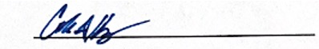
Cole I. Heap
Professional Geologist No. 10052
Exp: May 31, 2026

Purpose
Aera Energy LLC (Aera Energy, Aera), a subsidiary of California Resources Corporation, is requesting a review of Underground Injection Control (UIC) Class II Water Injection Project(s) with the intent to consolidate all Aera operated active water injection projects for the Pico Formation in the Ventura Avenue Oil Field (Ventura Field). The primary purpose of these waterflood injection projects is to provide injection support to the hydrocarbon producing sands located in the Ventura Field.
All active and inactive injection wells are contained within the existing UIC project(s). Currently, Aera Energy recognizes 18 active UIC projects; however, this project review is to consolidate three projects into one. The consolidation projects include 8140012, 8140016, and 8140024, which are all within the T410 fault block discussed throughout this project review document and highlighted in the regional map of the Ventura Oil Field in Figure 1. These projects are also listed in Table 1. This project review has been prepared following the project data requirements specified in the California Code of Regulations, Title 14, Section 1724.7 and the format outlined in the UIC Project Data Requirements Checklist from the Department of Conservation, California Geologic Energy Management Division (CalGEM).
Figure 1: Project Area – The project area is defined by the composite of 3 individual UIC projects
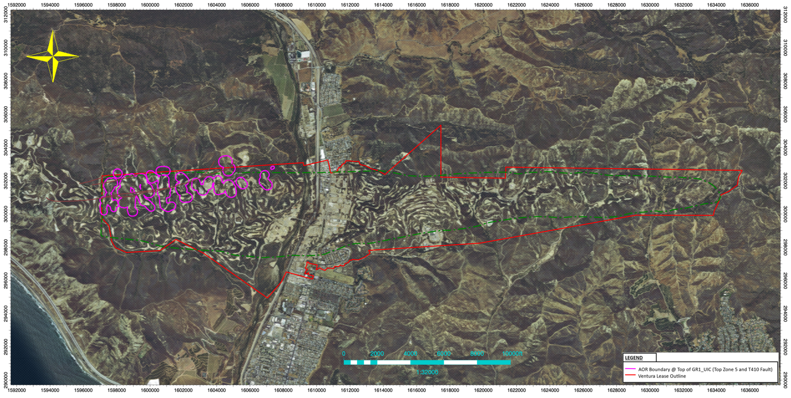

Table 1: Ventura Field Active UIC Projects for Consolidation
District Number | Status | Operator Code | Operator Name | Project Well Type | Field Code | Project Code | Injection Zone | Abbreviated Project Name | Pool Code | Original Approval Letter Date
2 | Active | A0610 | Aera Energy LLC | Waterflood | 814 | 8140012 | 5(NT-410) - Pico (Pliocene) Formation | 5N410 | 55 | 11/14/94
2 | Active | A0610 | Aera Energy LLC | Waterflood | 814 | 8140016 | 6-N/T-410 - Pico (Pliocene) Formation | 6N410 | 60 | 1/14/94
2 | Active | A0610 | Aera Energy LLC | Waterflood | 814 | 8140024 | 7-N/T-410 - Pico (Pliocene) Formation | 7N410 | 70 | 11/4/71

Background
The Ventura Field was discovered in the late 1800s and early 1900s with commercial production of hydrocarbons starting in the early 1920s. Over the next 40 years, primary development continued as technology was developed to drill to deeper zones. In the early 1920’s, discovery wells were drilled in the A and B Blocks to depths of approximately 4,000’ with the first 100+ barrels of oil per day (BOPD) well coming from the C-Block to ~5,500’. In the early 1930’s, drilling below the Barnard Fault into the D-Block was initiated with worldwide drilling depth records set several times over the next 15 years. Primary development continued with multiple drilling rigs. In 1974, an exploratory well (TAY653, API# 041112045800) was drilled to 21,500' into the Monterey Formation. Three intervals in the Monterey zone were tested but were not deemed commercial and the well was plugged back to 13,575'. During the late 1950’s operators of the field started to evaluate secondary recovery methods utilizing waterflood techniques. The various operators permitted, managed, and operated waterflood projects within their respective leases and production zones. As drilling techniques advanced, waterflood projects were implemented in the deeper zones. The purpose of implementing the waterfloods was to recover hydrocarbons which would not be producible under primary recovery conditions due to reduced reservoir pressure. In this process, water is injected to re-pressurize and sweep oil to the producer wells in the reservoir.
Over the last 50+ years, applications for new waterflood permits have been submitted for approximately 30 projects. The original application dates of each UIC Project are included in Table 1 (located in Section 2 above). Each waterflood project has a Project Approval Letter (PAL), which details the conditions whereby the project can continue to operate. Aera Energy meets with the CalGEM on an annual basis for Project Reviews, where in the past, CalGEM would issue a recertification letter for the projects following the meeting.
Today, Aera Energy manages a total of 18 active waterflood projects (UIC projects: 8140001, 8140002, 8140004, 8140006, 8140009, 8140011, 8140012, 8140013, 8140016, 8140017, 8140018, 8140019,8140020, 8140021, 8140022, 8140023, 8140024, 8140028). These projects are within the field boundaries of the Ventura Field and are in many cases stacked projects covering the multiple zones in the various fault blocks of the field, as shown in Figure 2. Thus, a consolidation of these projects into eight new UIC projects makes sense as all the current projects are within the stacked turbidite Pico and Repetto sands of the Pico formation. This project review focuses on what has come to be known as “Group 1”; namely dealing with existing UIC projects, 8140012, 8140016, 8140024, found within the T410 fault block. Copies of the current Project Approval Letters (PALs) may be found in Appendix A. The currently approved UIC projects are between the top of the Zone 2 and bottom of Zone 8, which corresponds to the S through HT sand markers. Each of the sands within the zones and faults blocks are included in at least one of the approved UIC projects. The relationship between sand units, zones, and faults blocks is discussed in Section 4 (Geological Study). Many of the wells intersect multiple permitted UIC projects and injection is reported for each approved UIC project.
All gross production from Ventura Field is operated by Aera Energy and processed at the Dehydration Plant located within the field. The facility removes water from the hydrocarbons to meet hydrocarbon sale specifications. The produced water is treated and re-injected into the reservoir via Class II injection wells to help the reservoir maintain its reservoir pressure and assist in secondary recovery of hydrocarbons.
Figure 2: Cross-section along the axis of the anticline illustrating the lateral and vertical extent of UIC projects permitted within the Ventura Field
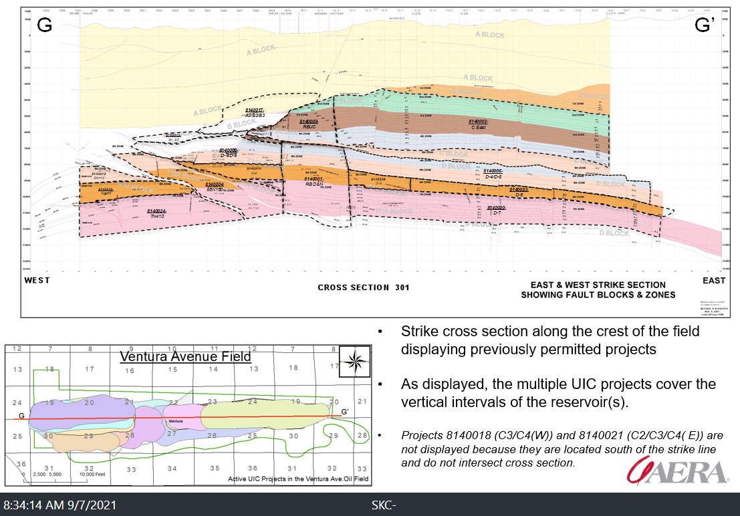

Geologic Study

GS(1)
Geologic information describing the reservoir characteristics of the injection zone, such as porosity, permeability, average thickness, areal extent, fracture gradient, original and present temperature and pressure, and original and residual oil, gas, and water saturations. The scope of the geologic characterization shall encompass the caprock and sealing mechanisms, the injection zone including the vertical interval above and below the approved injection zone, and the areas where potential migration of fluid or entrapment of migrated fluid could occur. The Division and Water Boards agree all supporting data shall be the most current, accurate and relevant. All data sources shall be cited.
The Ventura Field has been extensively studied over time by various operators and subsurface researchers. The field has more than 100 years of production history and is estimated to contain 4 billion barrels of oil in place. The earliest reports of hydrocarbons date back to 1855 when a shallow water well on what is now the Barnard lease encountered brackish water and a small amount of gas, and a scum of high gravity oil. The discovery well, Lloyd 1, was spud in 1914 and found light oil at 2,558 feet. Development under primary reservoir conditions occurred for close to 45 years through the late 1950’s, reaching peak production in 1954 at a rate of 78,500 BOPD. Waterflood operations began in the early 1960s as indicated in Figure 3, which shows the historical field production, water injection, and active well counts per year starting in 1922 to 2012.
Figure 3: Production and Injection History for Ventura Field
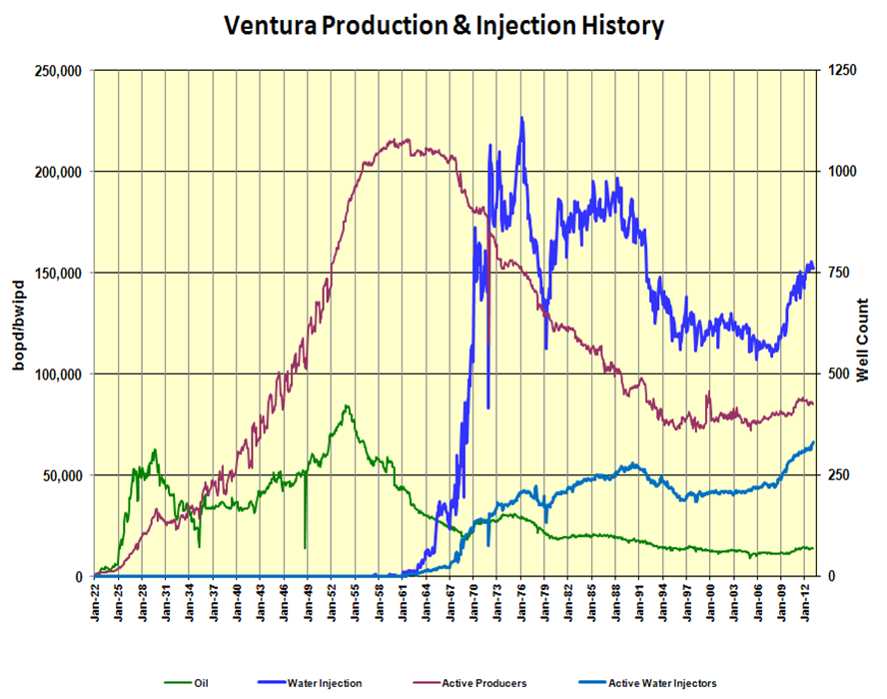

The Ventura Field is a structurally complex, faulted anticline with an east-west trending axis and bed dips ranging from 0 to 60 degrees. The productive interval consists of ~10,000 ft of thinly bedded Pliocene sands and interbedded mudstones at depths ranging from 4,000 feet to 14,000 feet. The major production zones are subdivided into 9 units, referred to as Zones 1-9, which are defined by regional mudstone markers which are correlated field wide, as displayed in the Type Log provided in Appendix GS-6. The markers (sometimes referred to as marker picks) noted on the Type Log are geologic horizons/beds that are easily identified by their distinct log character as wells as their lithology and provide the basis for which the strata are sub-divided into stratigraphically correlative rock units. The reservoirs within the Ventura Field are further compartmentalized by a series of north and south-verging thrust faults as displayed in Figure 4 and Appendix GS-5. The sealing capacity of these faults are evidenced by documented historical variations in reservoir pressure, water compositions, oil-water contacts, well performance, and reservoir models. Also noted on Figure 10, in bold black letters, is the fault block nomenclature used throughout the oilfield. The major fault blocks are designated by letters A, B, C, D, and N. The N-Block refers to a combination of Fault Blocks: H14, T180, and T410. The fault block nomenclature, in combination with the production Zones 1 through 9, provide the basis for which injection projects are defined. For example, in Table 2, the UIC project 8140017 is named A3/B2/B3; meaning this injection project is limited to Zone 3 in the A-block, Zone 2 in the B-Block, and the Zone 3 in the B-Block.
The oil-bearing sediments of the Ventura Field are of Pliocene Pico Formation. The Pico is composed of ~10,000 ft of interbedded, sandstones, conglomerates and mudstones deposited in deep marine environment. The lower Pico Formation, below the AO marker pick, is often referenced to as the Repetto Formation in literature, but is referred to here as a foraminiferal stage within the Pico Fm. The Pico Fm. ranges from depths > 15,000’ to surface, as displayed in Figure 4. Figure 4 is a modified regional cross section from Davis and Namson (1998).
Figure 4: Regional Cross Section displaying the Ventura Avenue Anticline
Outcrops and core have been studied extensively by Hsu,1977, Rotzien et al.,1998, and others which provide a basis for interpretation of the stratigraphic architecture in the subsurface. Sand bed thicknesses within the Pico Fm. range from inches to 10 ft. with an overall average of 2 ft; however, amalgamated sand bodies composed of many individual depositional units may have a thickness of up 100 ft. Reservoir properties including porosity, permeability and net-to-gross are summarized in Table ES-1 in Appendix – Engineering Study (ES) Tables. Sandstone porosities range from 5-25%, with an average of 15%. Generally, in sands with porosities below 10%, the permeability is too low for effective water injection for secondary recovery of hydrocarbons. The sands are interbedded and capped by mudstones that compartmentalize the reservoir into hundreds of individual flow units. Mudstone bed thicknesses range from centimeters to a few feet, but in composite, can exceed 90 ft. The thicker, more continuous mudstones act as flow barriers and subdivide the strata into 9 major production zones, Zones 1-9. The rightward deflection of the SP log and the leftward deflection of the resistivity log at electric log markers, AC, AO, AT, and DC are examples of these regional mudstones (see Appendix GS-6 for Type Log). Individual production zones range in gross thickness from 600 ft to over 1,600 ft with net sand thickness of 250 ft-1,000 ft.
Uplift associated with north-south compressional forces that formed the Ventura anticline have exposed the Pico Fm. at surface and resulted in crestal erosion that has removed an estimated 10,000 ft of section. Along the crest of the anticline, Quaternary sediments are generally limited to depths of less than 500 ft. and are confined to either valley fill within the lower Ventura River Basin, thin veneers of fluvial and alluvial sediments that fill erosional canyons, or landslide deposits, as displayed in Appendix GS-1 (modified USGS surface geology map).
Throughout most of the field where Aera operates, the Pico Formation outcrops at the surface (Dibblee & Ehrenspeck, 1992; Johnson, Ritchie, Seitz, & Gutierrez, 2013). In the central portion of the Ventura Oil Field, the Ventura River cuts through the Pico Formation north to south and Quaternary alluvium comprises the riverbed deposits. The Pico Fm. is underlain conformably by the Santa Margarita sandstone, a 2,500 ft thick section of Plio-Miocene, deep marine sands and shales. The lithology of the San Margarita is similar to the overlying Pico Fm. and is referred to as the 9th production zone. Underlying the Santa Margarita is the Monterey Fm. composed of organic rich, silicious shales that are considered the source rocks for the overlying hydrocarbon reservoirs. The deepest well drilled in the field, TAY653 (API #0403059484), drilled to 21,500’ penetrated the Monterey Fm. at ~16,500 ft. Oil and gas shows were abundant in the Monterey, but production tests were unsuccessful due micro-darcy permeability.
The Ventura anticline extends east-west for over 10 miles and fold limbs are well exposed at the surface. Dip measurements from outcrop along with more than 2,700 wells constrain the structural interpretation in the subsurface. The anticline is asymmetrical, with the northern limb dipping as high as 60°, whereas the southern limb is ~ 25°. The anticline plunges to both the east and west at ~5° from the approximate center of the field. The crest of the fold is offset at depth by two major thrust faults, the Taylor and the Barnard. The relationship of the faults is illustrated by the generalized regional cross section of Figure 4. The Barnard fault and parallel faults (T110, H14, T180, T410) are south dipping, north-verging thrusts with detachments in the underlying Monterey Fm. (Schwartz et al., 2007). The Taylor and associated Taylor-73 faults are north-dipping, south-verging thrusts with shallower detachments in mudstones within the Pico Fm. These faults create significant seals between fault blocks and compartmentalize the strata into separate reservoirs. Reservoir pressures, oil-water contacts, and water chemistry vary across these major faults.
Each UIC project has a unique combination of vertical and lateral containment features that can include structural controls (folds, faults), stratigraphic controls (confining mudstones), fluid dynamics (pressure differential) or reservoir properties (low permeability). In composite, the structurally controlled fault blocks, combined with confining mudstones and shales, make up continuous injection interval that extends from Zones 2 through 8 with depth ranges of ~4,000 ft to 13,000 ft (see Figure 2). On a field scale, the doubly plunging anticlinal fold, along with mudstones within the Pico Fm., provide broad lateral containment. Lower reservoir pressures near the crest relative to the flanks also provide additional lateral containment mechanisms.
Mudstones within Pico Fm. are one of the primary containment mechanisms. Figure 5 displays core from well TAY768 (API# 0411121954) and a grain size log generated from core descriptions (to the right of core photos) shows a typical fining-upward stacking pattern with coarse-grained sands (red) near the base that fine upward into mudstone (grey) at the top of the depositional sequence. Permeability measurements from core samples within mudstone intervals are extremely limited and average ~1 millidarcy (mD). The limited number of measurements are not sufficient to fully characterize the full range of permeabilities of these fine-grained rocks.
Figure 5: Core and log interpretation from well TAY768 (API# 0411121954)
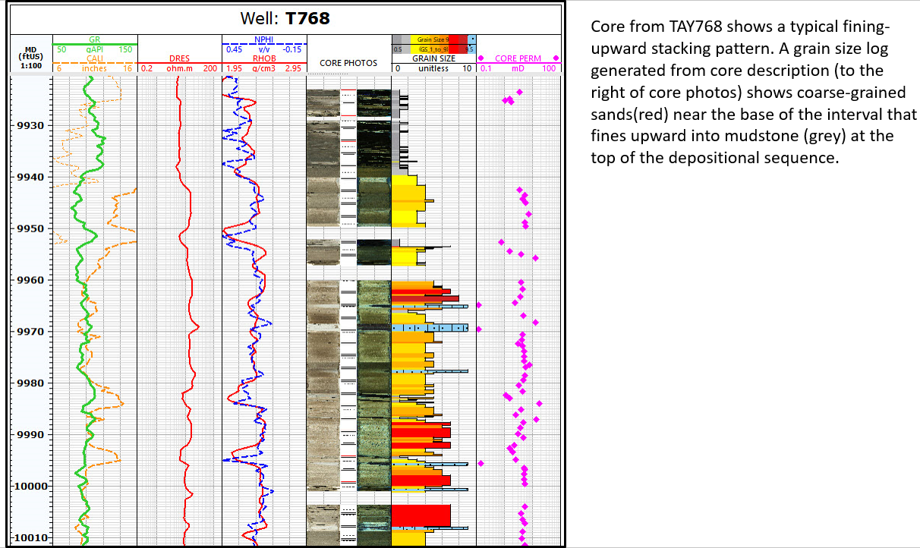
Nuclear magnetic resonance (NMR) logs that are calibrated to core provide an alternative method to characterize the range of permeabilities that exist within these zones. Figure 6 shows the permeability frequency distribution of zones with Vshale >90% derived from Nuclear Magnetic Resonance (NMR) logs from 5 different wells, where Vshale is defined as the volume of shale content within an interval. The mean permeability is ~0.4 mD, but values can range as low as 0.001 mD. These low permeability mudstones are present throughout all production zones and compartmentalize the sands bodies into hundreds of individual flow units. The ability of these mudstone intervals to confine fluids within an injection zone is demonstrated by reservoir pressure measurements. Sands separated by mudstones within a single production zone can have several hundred PSI (pounds per square inch) difference in reservoir pressure as seen in Figure 7. Low permeability mudstones in such as those described, provide overlying containment (see cross section in Appendix GS-5 and Type Log in Appendix GS-6). A minimum of 2,000 ft of interbedded sands and mudstones within Zone 1 provide numerous additional flow barriers above the injection zone. Similar mudstone intervals in the lower Zone 8 and upper Zone 9, along with high reservoir pressures in the underlying Zone 9 provide underlying containment and limit injection to the upper Zone 8.
Figure 6: Permeability Distribution from NMR data from five located across the field
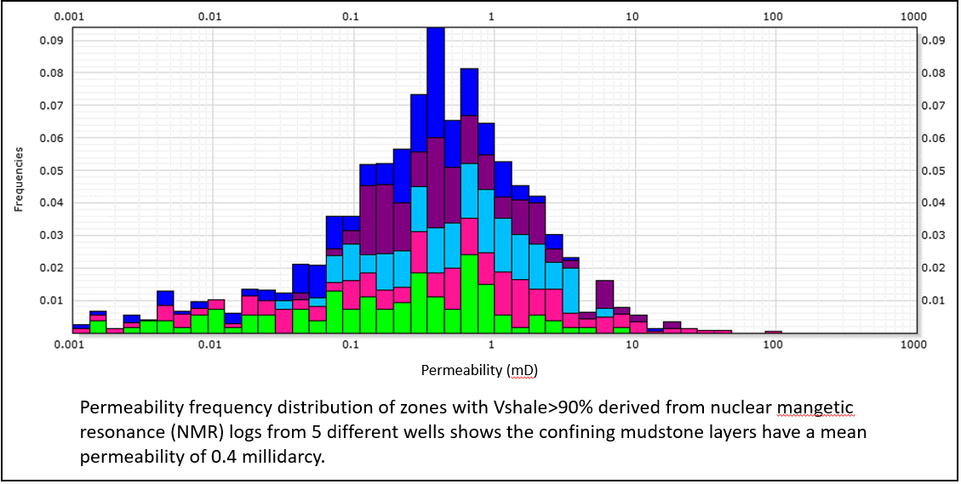
Figure 7: Reservoir Pressures as observed in well TAY793 (API# 0411122072)
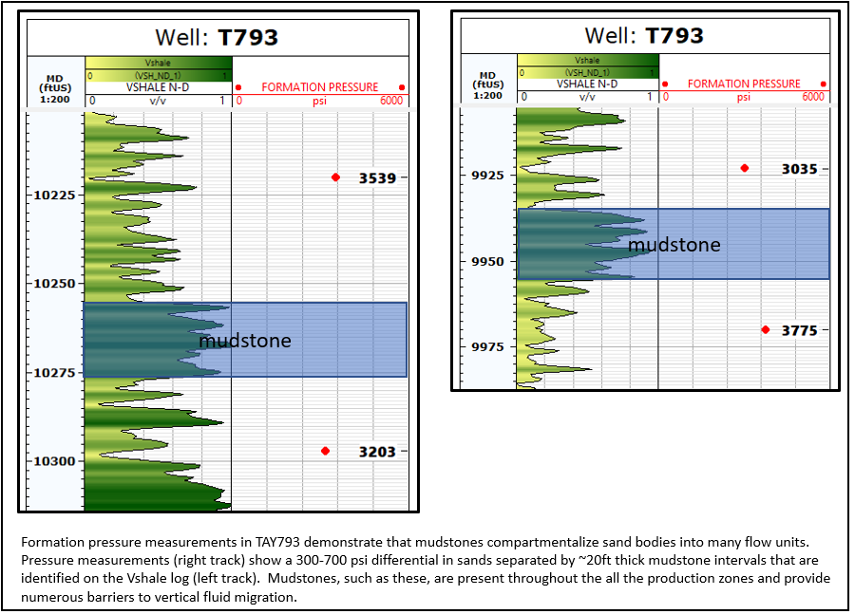
Thrust faults are the other major containment mechanism, which in combination with the mudstones, create overlying, and in some cases, underlying seals. Many of these faults can be identified on openhole logs as fault damage zones with higher resistivity and reduced porosity and permeability, relative to surrounding strata. Figure 8 displays core measurements that show reduced permeabilities within a fault damage zone. The sealing capacity of these faults is demonstrated by reservoir pressure measurements. Figure 9 shows that 1,000 psi pressure differential was maintained across the T410 fault during primary production in the 1950s. Figure 10 shows Cased Hole Dynamic Tester (CHDT) measurements taken in TAY350 (API#0411105197) that are projected onto a north-south dip-section. The faults are highlighted in red (in Figure 10), and the CHDT pressure measurements show 1,000-2,000 psi difference across the T110 fault.

Figure 8: Permeability as measured in core above, within, and below Taylor Fault Zone
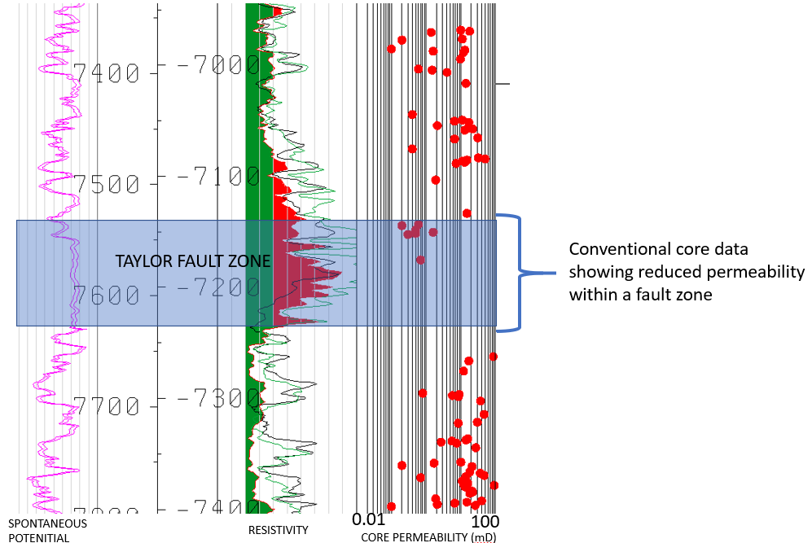

Figure 9: Observed Bottom Hole Pressure Variations Across Fault Taylor 180 Fault Block and Taylor 410 Fault Block
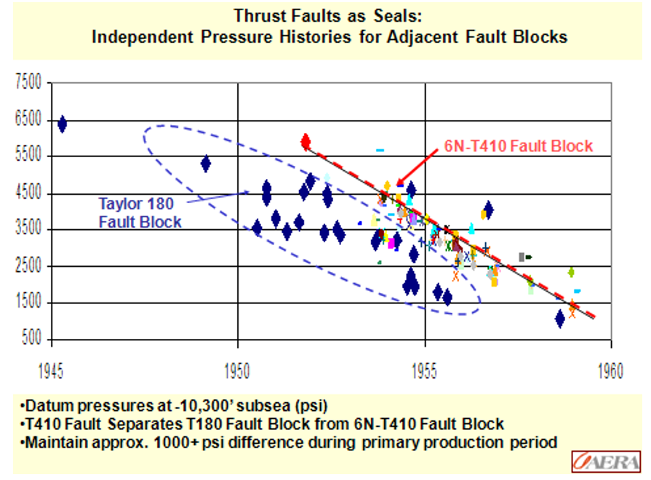

With the Ventura Field’s turbidite systems, consisting of interbedded sands and mudstones, these demonstrate excellent sealing capacity that prevents the vertical and lateral migration of fluids out of the injection zone. The rhythmic layering of sand and shale, characteristic of turbidite deposits, creates a series of natural flow barriers. Thick, low-permeability mudstone layers, interspersed within the sand bodies, effectively compartmentalize the reservoir into hundreds of flow units. Mudstone permeability averages around 0.4 millidarcies, with some intervals reaching values as low as 0.001 millidarcies, ensuring minimal fluid migration. Pressure differentials of several hundred psi between sands separated by these mudstones further demonstrates the effectiveness of these shales and mudstones as confining units.

Additionally, structural features such as thrust faults complement the stratigraphic barriers, creating robust containment mechanisms. The faults, characterized by reduced porosity and permeability in fault damage zones, maintain significant pressure differentials across fault blocks, as observed in reservoir pressure measurements. For example, the T410 fault exhibited a pressure difference of over 1,000 psi during primary production. Combined with the broad lateral containment provided by the doubly plunging anticline structure, these turbidite systems ensure that injected fluids remain securely confined within the targeted zones, enhancing the reliability of injection projects.
Figure 10: Cased Hole Pressures varying by Depth along well TAY350 (API#0411105197)
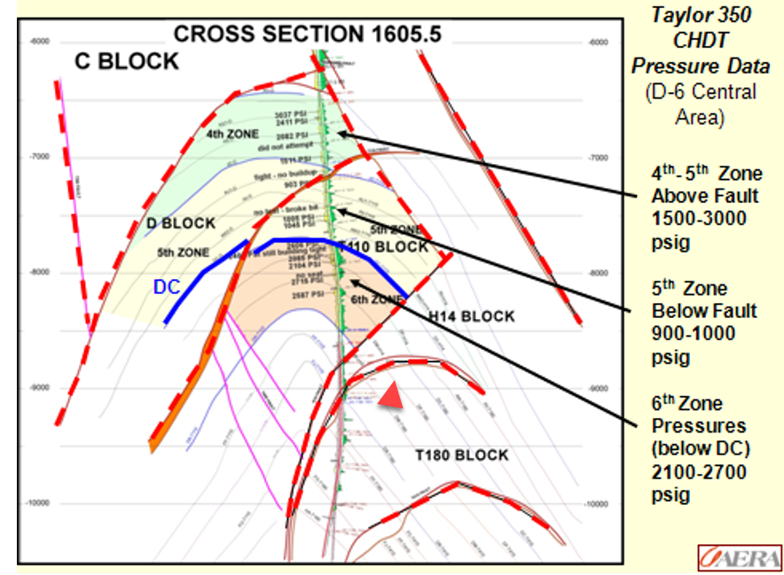

GS(2)
Reservoir fluid data for the injection zone, such as oil gravity and viscosity, water quality, presence and concentration of non-hydrocarbon components in the associated gas (such as hydrogen sulfide) and specific gravity of gas. Liquid analysis of the reservoir fluid shall be performed in accordance with Section 1724.7.2. The Division and Water Boards agree supporting documentation for formation fluid TDS determination should be included and from actual samples when available. Supporting documents may include, but are not limited to, historic data, properly documented log derivations, and when available, submission of LAS logs and all constants used for verification.
Reservoir Fluid Data – Hydrocarbons
Hydrocarbon fluid properties (oil gravity and viscosity, non-hydrocarbon components in the associated gas, and the specific gas gravity) for each injection project (UIC Project) are provided below in Table 2. Reservoir hydrocarbon fluid property data vary not only between different injection projects but can also vary within an injection zone based on depth.
Table 2: Reservoir Fluid Data (Hydrocarbons) by Injection Zone with Consolidation Projects Highlighted
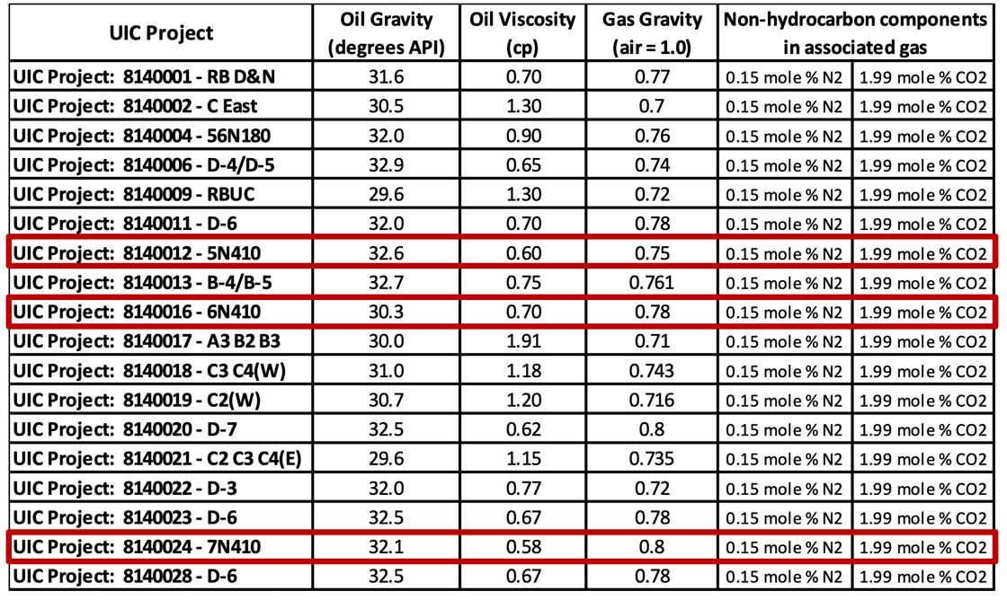
Water Quality Data - Formation Fluid Total Dissolved Solids (TDS)
Formation fluid TDS determinations are available from multiple sources:
      - Initial salinities for the Ventura Field ranged 17,100-23,085 ppm NaCl for the waterflood zones (equates to 21,300 – 27,285 ppm TDS). These data are provided in the Geologic Study Appendix.
- 2016 Non-Demonstration Aquifer Exemption Submittal to State Water Board and CalGEM. More details are available regarding the 2016 Non-Demonstration Aquifer Exemption Submittal in Sections WIP-4 and WGS-4.
  - 22 producing intervals were sampled with current TDS concentration ranges between 14,000 to 26,000 ppm. Geochemistry reports containing these data are included in the Geologic Study Appendix (GS-2-Initial Formation Salinities).
- Injection Plant water samples obtained annually for the UIC Project Reviews with CalGEM staff (refer to section WIP-3 for more information). See Table 3 below for recorded samples.
  - 2020 Geochemical analysis at the Injection Plants ranged from 19,414-21,971 ppm TDS and are consistent with 2015-2019 samples. The Geochem analyses are from the injection plant(s) referenced in Appendix WIP-3.
Table 3: Geochemical Analysis of Samples Collected from Injection Plant(s)
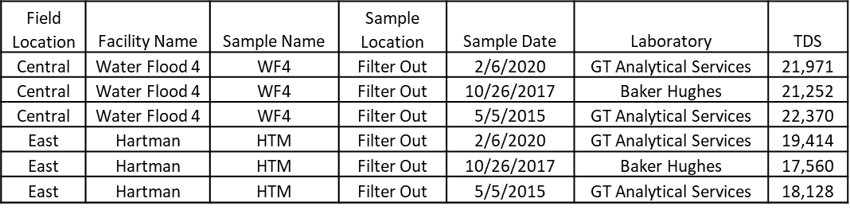
- Producing wells (see Sections IP-8, WGS-3, and WGS-5)
  - Periodic sampling from producers for surveillance and waterflood management
    - Salinity data from 1972-1987
    - Since 2007, 241 producer geochemical analyses obtained with TDS ranging from 14,146 to 33,406 ppm.
  - Production Wells- 33 samples from producer wells (water) (injection water make-up wells) with an average TDS of 27,861 ppm (see Table 4 below).
Table 4: Geochemical Analysis of Production Wells (water)

GS(3)
Structural contour map drawn on a geologic marker at or near the top and base of each injection zone in area of review, indicating faults and any lateral containment features. If faults are identified, there must also be analysis addressing whether or not the faults are capable of confining fluid to the approved injection zone and any geologic features that could result in the migration of fluid out of the approved injection zone. If a GIS shapefile is submitted, layers with labeled wellbore paths of all existing and proposed wells in the map area would lead to a more comprehensive understanding of the system.
Geological containment of fluids is discussed in section GS-1. Combined ZEI were used to define the project area, as well as to identify all wells within the project boundary, including producers and injectors, are included in the UIC Project Well List(s). UIC Project boundaries and associated injector wells are displayed on the maps found in Section GS(4). Figure 11 shows the top of the T410 fault block and is contoured on the base of the fault. Figure 12 exhibits the contoured structural base of the injection zone. Both maps may also be found in the Geologic Study Appendix in a higher resolution. The structure contour maps represent the geological marker at or near the top of this combined UIC project. Due to the nature of the geology in the Ventura Field, multiple structures are included to cover aerial zone extent in some projects; this includes defined geologic surface markers and fault markers.
Figure 11: T410 Fault Block Top Injection Zone Structure Map
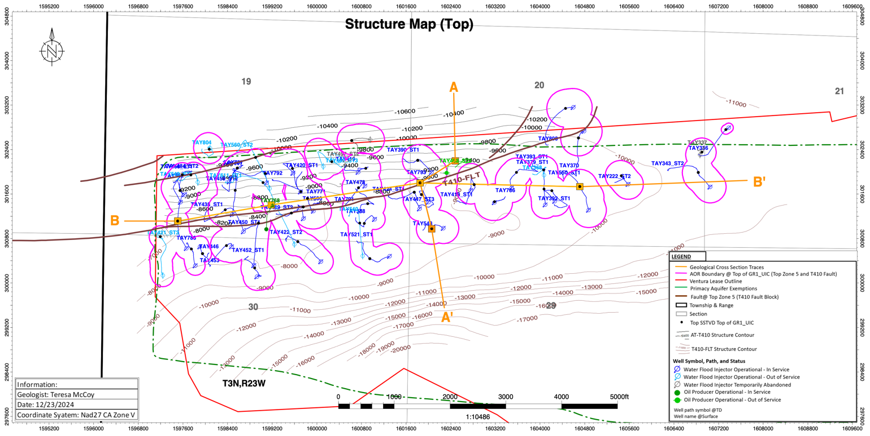
Figure 12: T410 Fault Block Base Injection Zone Structure Map
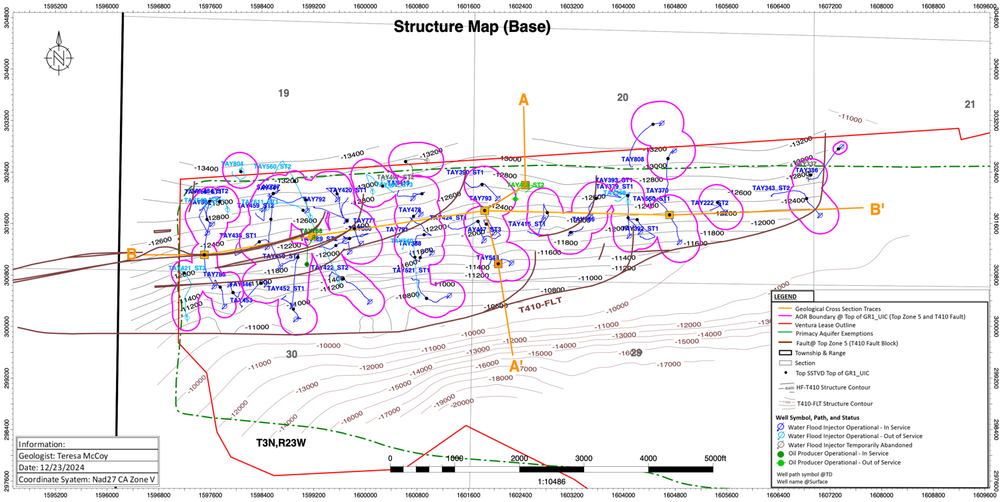

GS(4)
Isopach map of each injection zone or subzone in the area of review.
An isopach map for the consolidated T410 UIC projects is exhibited in Figure 13 in true vertical thickness (TVT). Representative zones indicating total true vertical thickness of each original project are provided in the Appendix – Geologic Study (GS) GS-4. Isopach maps cover the vertical extent of the UIC project(s) as indicated in the cross sections included in Section GS(5) as well as the generalized project consolidation area shown in Figure 1.

Figure 13: T410 Fault Block Zone of Injection Isopach
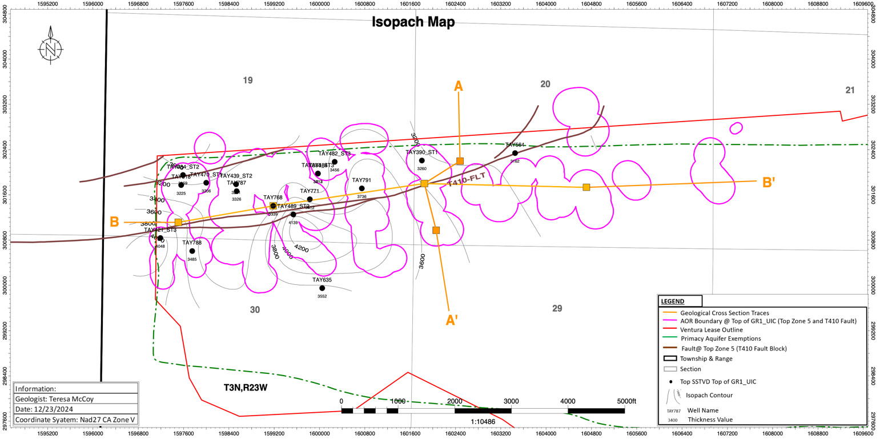

GS(5)
At least two geologic cross sections in the area of review through at least three wells, including one injection well. As near as possible, one of the geologic cross sections shall be along strike and the other shall be perpendicular to strike. The cross section shall extend from the base of the deepest production or injection zone to surface and indicate the location of the approved injection zone, the base of freshwater, and the base of the USDW.
Two geological cross sections have been created; Figure 14 is a dip section of A to A’ running north to south. Figure 15 is a strike section of B to B’ running west to east. Locations of cross section lines are displayed on each respective structure and isopach map herein. As a reference, a typical cross section with the production intervals highlighted is displayed in Figure 16. All cross sections and map are also provided at a higher resolution in Appendix – Geologic Study (GS) Figure GS-5.
Figure 14: Geologic Dip Section A - A'
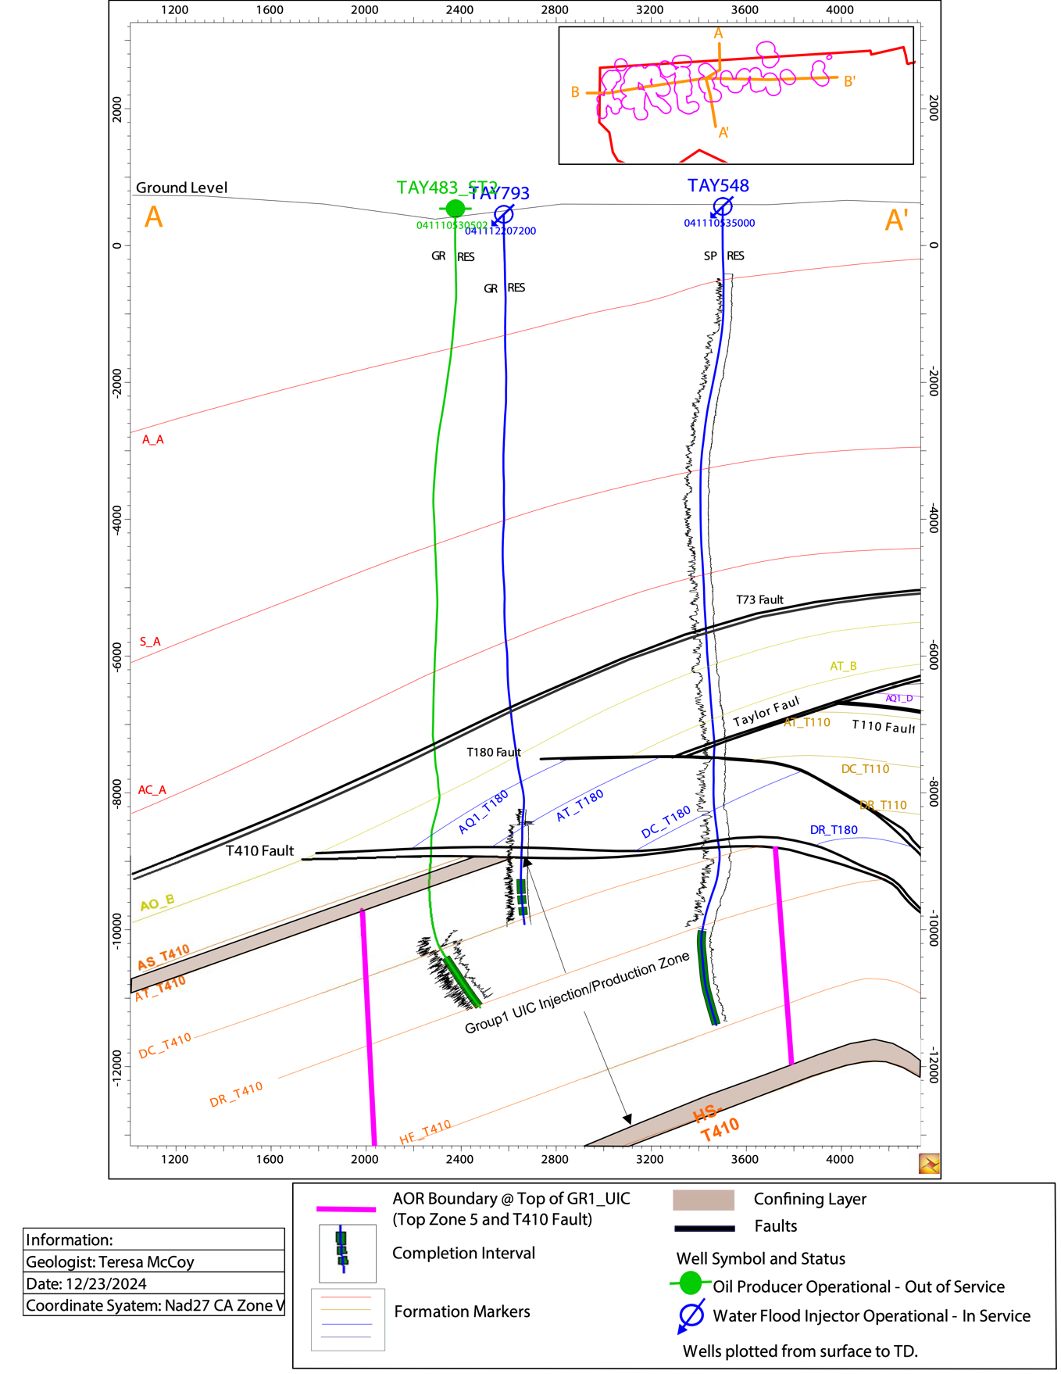
Figure 15: Geologic Strike Section B - B'
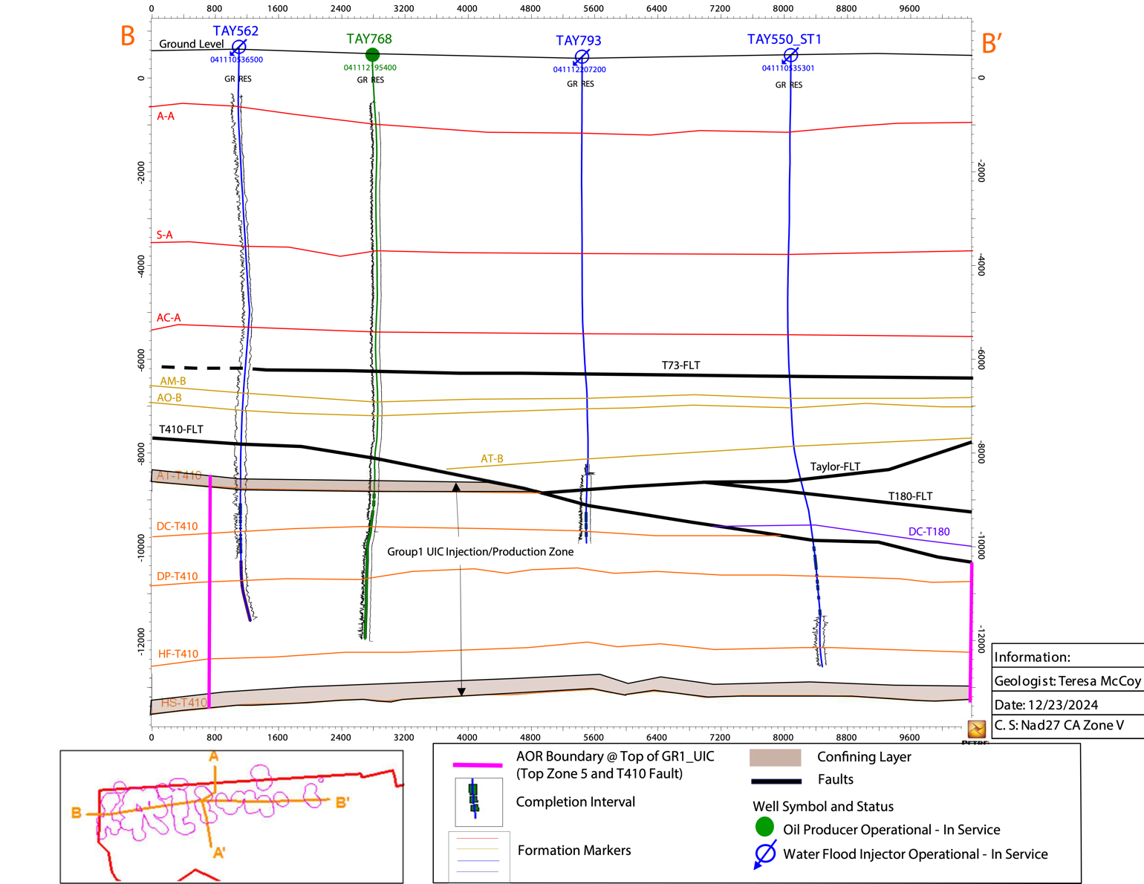
Figure 16: Typical Cross Section of Ventura Avenue Oil Field Displaying Production Intervals and zones within Respective Fault Blocks
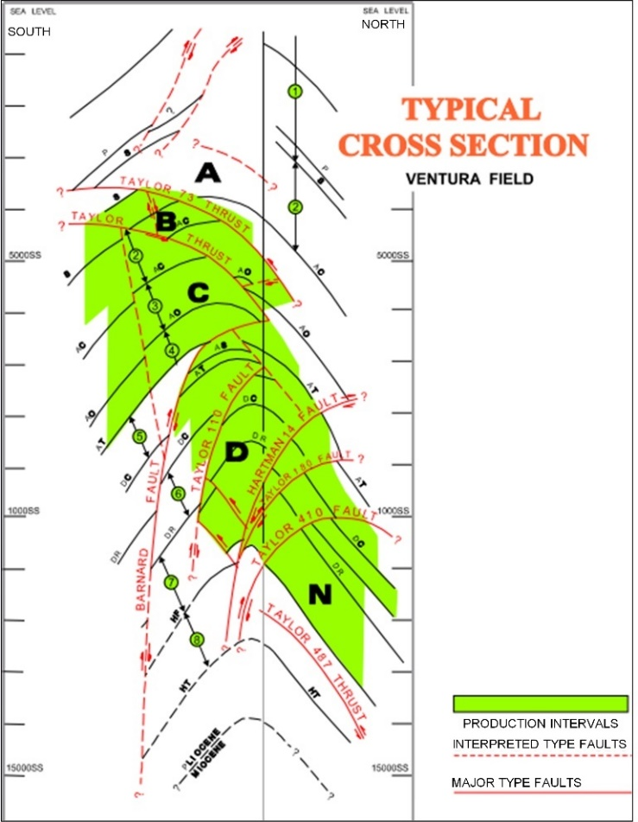

GS(6)
Representative electric log to a depth below the deepest producing or injection zone, whichever is deeper, identifying all geologic units, formations, USDWs, freshwater aquifers, and oil or gas zones. The electric log shall identify the API number of the well that was logged.
An electric log to represent the type log for the Ventura Field is composed of multiple wells to provide a complete interval of the Pico Formation. The type log is of Well TAYLOR 768 (API# 0411121954). This type log exhibits Zones 1-8 found within the Pico Formation on the Taylor lease. The numerous shales of the top and base confining layers are designated in a tan/brown color. The zone of injection, within the T410 fault block, is highlighted in light yellow. The Type Log is provided in Figure 17 and may be found in higher resolution in the Appendix – Geologic Study (GS) (GS-6 – Type Log).
Figure 17: T410 Fault Block Type Log
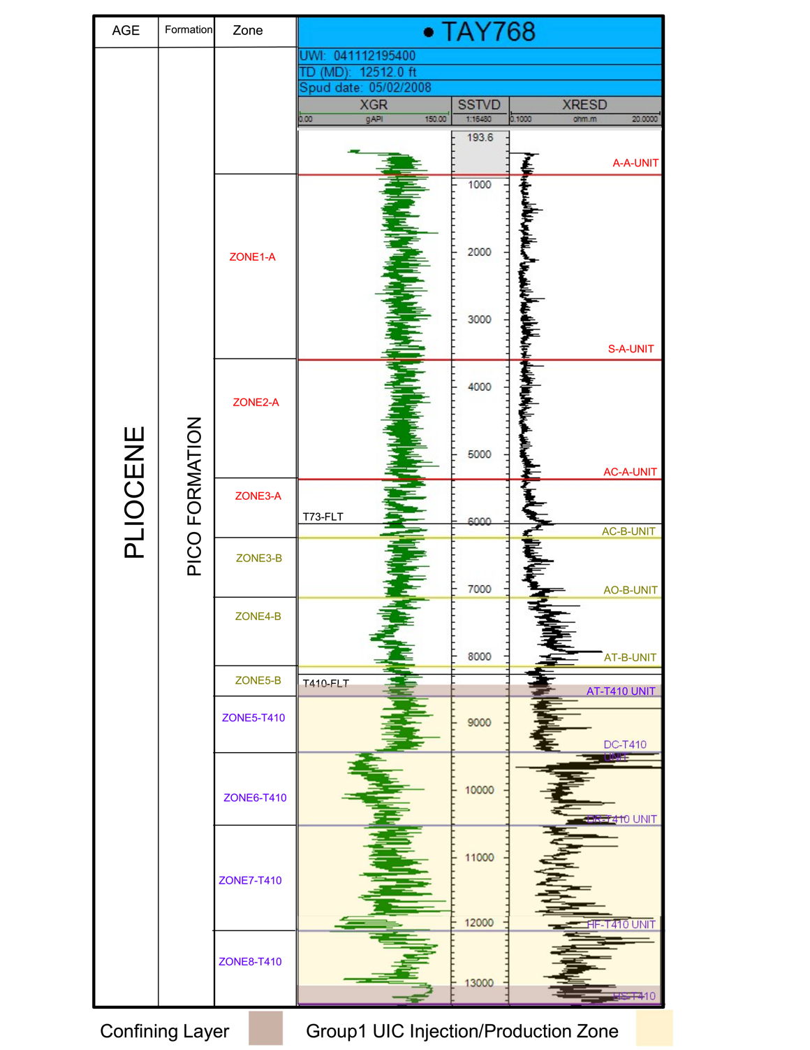
Base of 10,000 ppm TDS Interpretation
In early 2020, Aera initiated an effort to perform petrophysical analysis on selected wells to help refine the Base of < 10,000 ppm interpretation.
Base of < 10,000 ppm depths on the wellbore diagrams are determined from one of the following methods:
- Spontaneous Potential
- Estimated from offset calculated wells Spontaneous Potential
Spontaneous Potential method
The Spontaneous Potential (SP) method was utilized to calculate the depth in a well bore at which the salinity is calculated to be greater than 10,000 ppm. The Spontaneous Potential (SP) method uses an SP log, mud resistivity, and temperature to calculate formation water salinity. This method and equations utilized are described in the EPA’s 1988 Survey of Methods to Determine Total Dissolved Solids Concentrations (KEDA Project No. 30-956), Chapter 4.2, in Schlumberger’s Log Interpretation Charts (SP-1 and SP-2), and USGS Water-Supply Paper 232- Using Geophysical Logs to Estimate Porosity, Water Resistivity, and Intrinsic Permeability. This SP method has been performed on approximately 150 wells across the field.
Strategy
The following approach is used to report Base < 10,000 ppm on the wellbore diagram where the exempted Pico Formation is not present at surface:
- For the 150 wells in which SP method has been applied, then the depth calculated by the SP method is reported.
- If the SP method could not be applied on the well, then the depth of a nearby well on strike is estimated to the requested well.
However, it must be noted that the River Bottom area of the Ventura Oil Field is identified by the presence of Quaternary alluvium. The Ventura River contains freshwater with less than 3000 mg/L TDS. Wells penetrating the River Bottom area penetrate freshwater and therefore USDW. Wells outside the River bottom area do not penetrate a USDW because they are located within the surface outcrop of the Pico Formation and are either within the Pico Formation Aquifer Exemption Boundary or are within the CalGEM Administrative Boundary and are designated as non-USDW according to CalGEM Field Rules (Aera Energy Ventura Oil Field USDW Demonstration, May 22, 2024; Ventura Field Rules, CalGEM, March 1, 2007). Therefore, no USDW is present nor represented on the type log in Figure 17.

W-GS(1)
All supporting maps (e.g. structural contour map) need to include the AOR and Project Area, existing exemption boundaries, faults (with displacement information), lines of cross-section, a scale, an explanation describing what the symbols and colors used represent, north arrow, and identify the name of formation or unit mapped. Also, structural contour and isopach maps of the upper and lower "confining" units need to be provided. Representative permeability and porosity values, if available, of the "confining" units should be labeled on these maps. The cross sections need to include the AOR(s), the proposed injection zone, confining units, the formation or units penetrated by injection wells with associated API numbers, water supply wells, locations of the base of fresh water (BFW) and USDW, deviated wells within the line of section (i.e. wells near the cross-section trace), and an explanation describing what colors and symbols mean.
Please see Sections GS(3) for structural contour maps, GS(4) for isopach maps, and GS(5) for cross section lines.

W-GS(2)
The type log provided will include labeled geophysical curves and a vertical scale. The method and data used to determine the base of USDW should be included in the application.
Please see Section GS(6) for Ventura Field Type Log.

W-GS(3)
Provide representative water quality data (collected within the past 5 years) of the injection zone from well(s) located within the AOR. The injection zone groundwater analysis should be representative of the reservoir groundwater in its native condition. The groundwater analyzed shall be either sampled from the injection zone itself prior to commencement of any injection into the reservoir or sampled from an analogous reservoir that has not already received injection fluid. The representative sample shall be recovered after all completion and drilling fluid has been circulated from the wellbore. Any proposed groundwater sampling and analysis proposed for new or modified projects must follow the most recent version of the Notice to Operators – Guidelines for Collection of Oilfield Water Quality Data
Please see sections GS(2) and IP(8) for representative groundwater analysis of injection zone(s). The Pico Formation is also an exempted aquifer within the primacy boundary.

W-GS(4)
If the injection zone is not an exempted aquifer, then a non-USDW determination shall be made using recent (collected within the past 5 years) water quality samples of the injection zone groundwater within the Project Area. If no wells exist within the Project Area, then total dissolved solids (TDS) well log calculations can be used provided that: 1) The accuracy (i.e. percent error) of the computed result is validated with a water quality sample of the same injection zone groundwater within 1 mile of the project area; and 2) The method, calculations, and assumptions used in the TDS analysis are provided. If the Operator determines through water quality sampling or TDS calculations that the injection zone and/or overlying formations are non-USDWs, the lateral and vertical extent of this determination shall be defined on the application maps and cross sections.
See Section WIP(4) and GS(6). The Pico Formation is also an exempted aquifer within the primacy boundary.

W-GS(5)
Any groundwater quality data or well log analysis that will be used to justify the injection of fluids (e.g., showing that TDS concentrations within the proposed injection zone are greater than 10,000 milligrams per liter) must be accompanied by a written statement or report, prepared by a state-registered professional geologist or professional engineer, indicating the degree to which the water quality data is representative of the injectate fluid or native formation groundwater and provide justification for that conclusion.
Since early 2007, Aera has collected 241 water samples from producers for the purpose of waterflood surveillance and management. Full geochemical analyses were run for these wells with the TDS ranging from 14,146 to 33,406 ppm. These 22 samples are consistent in their ranges. Appendix W-IP(4) has the last 5 years of geochemical analysis data for the producing wells. See Section IP(8) for representative groundwater analysis of water with TDS greater than 10,000 ppm.

Engineering Study

ES(1)
A description of how the area of review was determined, including calculations, variables, citations, and assumptions. The Division and Water Boards agree the AOR determination should include injection and production impacts of offset projects that could potentially interact with the proposed project, with due consideration for the geology, engineering aspects, and the nature of injected fluids. The Division may use the rates, pressures, and volumes included in the calculations as conditions of the Project Approval Letter. For water disposal projects, a determination of the current injectate front and pressure front also may be an important part of the area of review determination.
Introduction
The calculated zone of endangering influence (ZEI) radius defines the area of review (AOR) for each injector in the UIC project. The ZEI is a volumetric calculation using the Warner and Lehr volumetric method (Warner and Lehr, 1977) and represents the area that injected fluids could occupy.
To support the volumetric AOR determination and to ensure confinement of the injected water, an evaluation of the maximum potential reservoir pressure increase anticipated during the duration of the project is provided using Warner methods (Warner, 1979). This evaluation has two parts. First, the radius of pressure influence of each injector is determined which calculates the maximum reservoir pressure buildup at a specific radius from the injector for the duration of the project. Second, the potential reservoir pressure buildup from overlapping ZEI areas is determined using the principles of superposition. The superposition calculation evaluates the reservoir pressure at any location in the reservoir and considers both the pressure buildup due to injectors and the pressure drawdown due to producers.
Reservoir Parameter Summary
The values for the parameters used in the ZEI and pressure buildup equations are listed in Table ES-1 of Appendix – Engineering Study (ES) Tables. The reservoir parameters represent average values for the T410 fault block and were derived from log and core analysis.
The average gross reservoir thickness in the T410 fault block is 3299 ft which is based on 19 wells shown in Table ES-2 of Appendix – Engineering Study (ES) Tables. These 19 wells are the only wells that have logs through the entire T410 fault block. The net reservoir or sandstone is defined as containing less than 30% shale. The average net reservoir thickness (h) for these 19 wells is 1309 ft which equates to 0.397 net to gross ratio.
The average porosity (φ) value of 15.29% was calculated using triple combo log analysis of TAY768 (API 0411121954) over the net sand interval of the T410 fault block. A triple combo log is a special log that includes density and neutron logging measurements to accurately calculate the porosity. TAY768 is the only well in the T410 fault block that has a triple combo log.
The initial pressure (P_{i}) varies throughout the field and ranges between 73% and 97% hydrostatic pressure as shown in Table ES-3 of Appendix – Engineering Study (ES) Tables. The pressure data is based on 15 wells and provides good coverage throughout the reservoir as depicted on the isobaric map shown in Figure ES-8 of Appendix – Engineering Study (ES) Figures. The measured pressure data for each well is normalized to the datum depth of 11,155 ft TVD which is the average perforated depth in the T410 fault block for all wells completed in the T410 fault block.
The production rate (q) is based on the five-year average production rate allocated to the T410 fault block which is listed in the “Superposition Rate” column in Table ES-4 of Appendix – Engineering Study (ES) Tables. The “Superposition Rate” column also represents the ZEI Injection Rate (q) for injectors. The ZEI injection rate for each well is also shown in Table ES-5 of Appendix – Engineering Study (ES) Tables and represents the maximum potential daily rate allocated to the T410 fault block. The maximum potential rate is defined as the maximum injection rate for each well allocated to the T410 fault block over the last five years. Injection allocations are determined using injection tracer surveys that determine which sands are taking injection and are conducted at least every two years. Some wells are comingled with zones belonging to other UIC projects, and rates not allocated to the T410 were not included in the Group 1 ZEI calculations. Some injectors have been operating at a low rate, significantly below the maximum allowable surface injection pressure for the last five years, and for these wells, the injection rate has been increased so that the ZEI injection rate represents the theoretical maximum injection rate if the well was operating near the maximum allowable surface injection pressure. Lastly, 18 of the 49 injectors in the Injection Plan are not currently active, and the plan is to reactivate these injectors as needed to balance and maintain the waterflood. All 18 inactive injectors have been forecasted for the entire 15-year project life as if they were to be activated immediately.
ZEI Calculation - Volumetric Methodology
The volumetric method for determining the area of review (AOR) for each waterflood injector is calculated using Equation 1 and Equation 2 (Warner and Lehr, 1977). The calculated radius in Equation 1 is corrected for dispersion in Equation 2 where r’ is considered the ZEI and defines the AOR for each injector. The calculated AOR radius for each injector shown in Table ES-4 is used to create the AOR map shown in Figure ES-1, Figure ES-2, and Figure ES-3 of Appendix – Engineering Study (ES) Figures.

$r=\sqrt{\frac{5.615qt}{πhϕ(1-So)}}$ Equation 1
where:
q = Water injection rate, bbls/day
t = Total injection time, days
h = Net reservoir thickness, feet
ϕ* = Porosity accounting for residual oil saturation to water: {𝟇*=𝟇 x (1-Sorw ), fraction(
r = Radius of influence, feet

Correction for dispersion is applied according to Equation 2 to provide the AOR radius.
$r^{'}=r+2.3\sqrt{Dr}$ Equation 2
where:
r’ = Radius of influence corrected for dispersion, ft
r = Radius of influence from Equation 1, ft
D = Dispersion coefficient (3 ft for sandstone per Warner and Lehr, 1977)

Radius of Pressure Influence for an Individual Injector or Producer
The equation for pressure buildup resulting from constant rate injection through a single well is Equation 3 (Matthews and Russell, 1967). Subtracting P_{i} from both sides of Equation 3 provides the pressure buildup (ΔP) as shown in Equation 4. For a producer, a negative sign is applied to the rate (q) in both equations.
$P_{r}=P_{i}+162.6\frac{qμβ}{kh}log\left(\frac{kt}{70.4ϕμcr^{2}}\right)$ Equation 3
$ΔP=162.6\frac{qμβ}{kh}log\left(\frac{kt}{70.4ϕμcr^{2}}\right)$ Equation 4
where:
P_{r} = Reservoir pressure at time (t) and radius (r)
P_{i}= Initial reservoir pressure, psi
q = Water injection rate or g, bbls/day
µ = Viscosity, cp
β = Formation volume factor, rbbl/STB
k = Permeability, md
t = Total injection time, days
h = Net reservoir thickness, feet
ϕ = Porosity, fraction
c = Total Compressibility 1/psi
r = Radius of investigation, ft

The pressure buildup for each injector in the UIC Project has been calculated at various radii as shown in Table ES-6 of Appendix – Engineering Study (ES) Tables. The radius can be varied to any distance to estimate the pressure at any point from the injector. The calculated pressure buildup shown in Table ES-6 does not include pressure effects from other producers or injectors; therefore, it does not depict an accurate picture of the reservoir. Fortunately, the effects of individual wells can be superimposed to obtain the combined effect of multiple wells which is discussed in the next section.

Anticipated Reservoir Pressure Buildup by Applying Principles of Superposition
The superposition equation evaluates the pressure at any selected observation point in the reservoir by summing the pressures caused by each of the individual injection or production wells as shown in Equation 5.
$ΔP={P_{r}-P}_{i}=162.6\left[\sum_{n=1}^{m}{\frac{q_{n}μ_{n}β_{n}}{k_{n}h_{n}}log\left(\frac{k_{n}t_{n}}{70.4ϕ_{n}μ_{n}c_{n}r_{n}^{2}}\right)}\right]$ Equation 5
Where n is the well number.
The superposition equation for this project was calculated using the injection and production superposition rates shown in Table ES-4 which are also mapped in Figure ES-4 of Appendix – Engineering Study (ES) Figures. The calculation accounts for all active producers and active injectors in the injection plan of this UIC project. The eighteen idle injectors are excluded because they will only be reactivated if a current injector becomes idle or production increases. The injector superposition rate is the same ZEI rate in Table ES-5 to calculate the ZEI. The producer superposition rate is equal to the five-year average gross (oil plus water) rate allocated to the T410 fault block. The X and Y coordinates at the top perforation of the T410 fault block for each well are shown in Table ES-4 which are used to obtain distances (r) to selected observation points in the reservoir.

Twenty observation points have been selected throughout the reservoir as mapped on Figure ES-5 of Appendix – Engineering Study (ES) Figures and listed in Table ES-7 of Appendix – Engineering Study (ES) Tables. The locations were selected for good coverage or where the pressure is expected to be highest due to overlapping ZEI areas. The current reservoir pressure (P_{i}) at each observation point is estimated based on the average reservoir pressure weighted by distance to the pressure survey well listed in Table ES-3. The weighted average is based on the inverse distance from the observation point to the pressure survey well, so that the closer the pressure data point is to the observation point the higher the weighting as shown in Equation 6. Only pressure surveys within 1500 feet from the observation point were considered in the weighted average. The current reservoir pressure throughout the observation points ranges between 79% hydrostatic pressure and 93% hydrostatic pressure. 100% hydrostatic pressure is assumed to have a pressure gradient of 0.44 psi/ft.

$P_{p}=\frac{\sum_{i=1}^{n}{\frac{P_{i}}{d_{i}}}}{\sum_{i=1}^{n}{\frac{1}{d_{i}}}}$ Equation 6

where:
P_{p} = Pressure at the observation point, psi
P_{i} = Pressure at each pressure survey point, psi
d_{i} = Distance from the pressure survey point to the observation point, ft

The superposition model results are summarized in Table ES-7. The reservoir pressure change (ΔP) calculated from Equation 5 is very small and ranges between -17 to 17 psi throughout the twenty observation points. This is expected because the waterflood has been maintained at a 1.0 injection to gross liquid ratio or less which is the plan for the remaining project life. The eighteen inactive injectors will only be reactivated if an injector fails or production increases so that the injection to gross ratio remains balanced. The pressure calculation demonstrates that the reservoir pressure should maintain a stable pressure profile over the life of the project.

ES(2)
A map of the area of review showing the location of the following: (1) All wells within and adjacent to the boundary of the area of review; (2) All water supply wells that are within the area of review and identified in public records or otherwise known to the operator; (3) Any underground disposal horizons, mining, and other subsurface industrial activities not associated with oil and gas production within the area of review, to the extent such information is publicly available or otherwise known to the operator; and (4) Traces of the geologic cross sections provided as part of the Geologic Study. The historical term 'project area' may be shown as the map view projection of the injection zone defined in 1720.1(g). The 'project area' can include a single area of review (AOR), multiple AORs, or any overlapping cumulative effects of the AORs.
A map of all wells within and adjacent to the AOR boundary of the UIC project is included in Figure ES-3, and these wells are listed in Table IP-3.
All wells located within the AOR boundary of the map are listed in Table IP-3 designated as “Yes” in the “Within AOR” column and shown in Figure ES-2.
Analysis regarding the search for known water supply wells within one-mile radius of the UIC Project boundaries is discussed in section W-ES(6).
The Ventura Field does not have any active subsurface disposal project(s), mining operations, or other known subsurface industrial activities not associated with oil and gas production within the boundaries of the UIC Project.

ES(3)
A compendium of the following information: (1) For all wells depicted in the map of the area of review (including water supply wells to the extent information is known or publicly available), the API numbers, or other identifying information for wells that do not have API numbers, and the wellbore paths, total depths, and depths of completion interval(s) of the wells; (2) The type and status of water supply wells depicted in the map of the area of review; and (3) All the casing diagram data specified in Section 1724.7.1, provided in the form of graphical casing diagrams or flat-file data sets, for all wells that are within the area of review and that are completed in or penetrating the injection zone for the underground injection project or a deeper zone, including directionally drilled wells that intersect the area of review in the injection zone or a deeper zone.
All wells within the UIC Project AOR boundary were reviewed for wellbore integrity, including primary cementing of the casing strings and liners during the drilling of the well, any changes during the lifecycle of the wells, and all plugging and cementing procedures during abandonment of the wellbore(s). There are a total of 186 wellbores within the AOR boundary. The wellbore schematic diagrams are included in Appendix – ES(3) – Wellbore Diagrams. There are a total of 423 wellbores on the AOR map in Figure ES-3 and Table IP-3 which penetrate the T410 zone of injection. 186 of the 423 wellbores are within the AOR boundary which are depicted in Figure ES-2 and Table IP-3 with the “Within AOR” column marked as “Yes”. Zero potential conduits to the USDW were identified in this project.
The wellbore schematic diagram includes the sand markers, which correspond to the approved project top and base are included either in table format or on the wellbore schematic adjacent to the wellbore mechanical. The presence of water with TDS less than 3,000 ppm is indicated in the Ventura Field near the Ventura River. Depth of water with TDS less than 3,000 ppm is indicated on wellbore schematic diagrams if penetrated by the well. The presence of water with TDS less than 10,000 ppm is indicated in the Ventura Field and depth of Base of < 10,000 ppm is calculated in accordance with the SP-Method (as discussed in section GS-6) and listed in the wellbore schematic diagrams.

ES(4)
The planned well-drilling and plugging-and-abandonment program to complete the project, including a flood-pattern map, if applicable, showing all injection, production, and plugged and abandoned wells, and unit boundaries. The Division recognizes plans are subject to change during the course of a project review. It is the operator's responsibility to update project data accordingly prior to approval.
Currently, there are no current drilling plans for the Ventura field. However, future infill or replacement well drilling or redrilling activity within the project may be proposed.
All idle wells will be tested or abandoned per the appropriate CalGEM regulations and workplans such as the Idle Well Management Plan and the Testing Waiver Plan. No well plugging-and-abandonment projects are required to complete this UIC project; however, the current plan is to abandon approximately 50 wells in the Ventura field in the year 2025. Three of these wells penetrate the T410 fault block: TAY516 (API 0411100287), TAY430 (API 0411105536), and TAY403 (API 0411102452).

W-ES(1)
Provide the rationale for determining the area of review (AOR) with supporting calculations; including the assumptions associated with the calculations. A range of values used to determine average porosity, permeability, and thickness (net and gross) will be provided with the supporting data. The anticipated project duration, anticipated daily rate of injection (by well), and anticipated cumulative net volume of fluid to be injected will be provided.
The rationale for determining the area of review is discussed in Section ES(1).

W-ES(2)
For all projects, AOR calculations must use an accurate representation of all the relevant parameters from within the project area, including the static pressures or current temperatures of the injection zone(s) and USDW(s) within the AOR. If a range of values for the input parameters is provided, then multiple AORs need to be calculated to provide the most conservative estimate of the distance injected fluids may migrate. This procedure will provide assurance that, if proposed, an AOR of one quarter-mile fixed radius is adequate. The analysis shall consider the heterogeneity of the reservoir. Operator must declare if the formations are homogeneous or heterogeneous. A ZEI calculation may meet the regulatory requirements of AOR calculation.
The ZEI and AOR calculations are included in section ES(1). There is no USDW in the injection zone. The current temperature ranges from 160 to 250 degrees F and the static pressure varies from 3,577 to 4,763 psi (73 to 97% hydrostatic pressure) normalized to a datum depth of 11,155 ft.

W-ES(3)
Provide an evaluation of any potential increase in reservoir pressure and fluid migration due to either overlapping ZEIs, neighboring injection projects, or other relevant inputs into the system (i.e. faults, facies changes and stratigraphic pinchouts that may act as flow barriers). If the change in reservoir pressure due to injections will be reduced by production wells, the Operator will submit calculations that show how the change in reservoir pressure will be offset by the production wells. Injection and production wells used in this evaluation should be identified on the application maps/figures.
An evaluation of any potential increase in reservoir pressure and fluid migration is included in section ES(1). ES(1) includes an evaluation of the maximum potential reservoir pressure increase anticipated during the duration of the respective project. A conservative superposition model of pressure changes caused by producers and injectors over the project life is discussed in ES(1), and the results show that reservoir pressure will not change significantly for the duration of the project. The wells used in the superposition evaluation of the potential reservoir pressure increase are mapped in Figure ES-4 and listed in Table ES-4.

W-ES(4)
The map of the AOR provided will also include the following: (1) for all wells; include surface and bottom hole locations and labels that display their well type and status (e.g. active steamflood injector); (2) all faults within the Project Area, and (3) all wells that have been identified as potential conduits to a USDW.
Maps have been created with these requirements. There are zero potential conduits to a USDW identified in this project.

W-ES(5)
Well construction diagrams for all wells and boreholes within the AOR need to be provided. Each diagram will identify the depth and perforated interval of the well and borehole, cement plugs, casing damage, key geologic markers (e.g. injection zone), BFW, and USDW. Each well and borehole diagram should depict the entire history (e.g. sidetracks, redrills, and other mechanical changes).
Wellbore diagrams have been created with these requirements and included in Appendix ES-3.

W-ES(6)
Provide a water well survey. Water well locations within one mile of the project area shall be presented on a map and listed in an accompanying table. The water well survey should utilize the following data sources (at a minimum): Department of Water Resources (DWR) well completion reports and GeoTracker Groundwater Ambient Monitoring and Assessment (GAMA) information system. The following information will be included in the table: location information, type (municipal, domestic, irrigation, industrial, stock), status (active, idle, abandoned, destroyed), owner, well completion depth and zone name, and depths for all screened intervals. On a case-by-case basis, an expanded water well survey may be necessary based upon potential risk to beneficial use water outside the limits of the AOR. For those well completion reports that do not provide the latitude and longitude coordinates, the Operator should attempt to determine its location by a field survey.
In 2024, Aera conducted an electronic search to identify the location of water wells within 1 mile of the UIC project boundaries. The data sources utilized include the Department of Water Resources (DWR) well completion report and the Groundwater Ambient Monitoring and Assessment (GAMA) information system. A direct connection to these databases was established in March 2024 and reassessed in December 2024. These data were set to display those wells within 1 mile of the UIC project boundaries and could include destroyed wells, monitoring wells, and cathodic protection wells, as well as industrial and domestic water source wells. The data from the DWR and GAMA systems were incomplete, and in some cases, the well type was not specified. These unspecified wells are included in the final dataset provided. The latitude and longitude coordinates from the DWR and GAMA systems are approximate and so the well locations as shown on the map are imprecise and resulted in wells having the same location. There are a total of forty-five wells located within 1 mile of the UIC project boundary. The information for these wells is tabulated in Table ES-8 of Appendix – Engineering Study (ES) Tables. The locations of the wells are mapped in Figure ES-6 of Appendix – Engineering Study (ES) Figures. Except for one monitoring well, all of the other 44 wells are outside of the project area, and all but two wells in section 26 are outside the administrative field boundary. Six of the wells are classified as ‘Cathodic Protection’, twenty-seven as ‘Monitoring’, four as ‘Test Well’, five as ‘Unknown’, two as ‘Water Supply Domestic’, and one as ‘Water Supply Industrial’. The status of these forty-five wells was not available from the DWR and GAMA databases. However, according to the Ventura River Watershed Management Plan published in 2015 (Walter, 2015), there were eighteen active water wells in the Lower Ventura River Basin (please see Figure ES-7 of the Appendix – Engineering Study (ES) Figures), most of which are used for agricultural purposes, and no public water suppliers use the basin. Please note that each of these wells are outside of the UIC project area.

References
Matthews, C.S. and Russell, D.G. “Pressure Buildup and Flow Tests in Wells.” Society of Petroleum Engineers (SPE) Monograph, Vol. 1, Society of Petroleum Engineers, Richardson, TX. 1967.
Walter, L. “Ventura River Watershed Management Plan.” Prepared for the Ventura River Watershed Council. March 2015.
Warner, D. and Lehr, J. “An Introduction to the Technology of Subsurface Wastewater Injection.” Municipal Environmental Research Laboratory, Office of Research and Development, U.S. Environmental Protection Agency. Oklahoma. 1977.
https://www.epa.gov/sites/default/files/2020-02/documents/an_introduction_to_the_technology_of_subsurface_wastewater_injection-dec1977.pdf
Warner, D.L., Koedertiz, A.S., Simon, A.,D., and Yow, M.G. “Radius of Pressure Influence of Injection Wells”. United States Environmental Protection Agency (US EPA). EPA-600/1-79-170. Robert S. Kerr Environmental Research Laboratory, Ada, OK. 1979. Available online at: https://nepis.epa.gov/Exe/ZyPDF.cgi/910110NU.PDF?Dockey=910110NU.PDF

Injection Plan

IP(1)
A statement of primary purpose of the project.
The primary purpose of the UIC project is to provide injection support to the hydrocarbon producing sands located in the T410 fault block of the Ventura field using an injection to gross liquid ratio (IGR) near 1.0. As shown in Figure IP-1 of Appendix – Injection Plan (IP) Figures, production began in the T410 fault block in 1942 and the waterflood began in 1963. Table IP-1 of Appendix – Injection Plan (IP) Tables shows the cumulative and current injection and production rates for the T410 fault block. The current total injection rate is 12,064 bpd, and the current total gross production rate (oil plus water) is 15,268 bpd. The cumulative IGR is 0.86. The current IGR is 0.79. The plan for the life of the project is to maintain balanced injection and production to maintain stable reservoir pressure throughout the field. Reservoir pressure is not expected to change significantly throughout the life of the project.

IP(2)
A map showing injection facilities related to the project, and piping and instrumentation diagram(s) for the injection facilities.
There are two main treating systems in the Ventura field: The Westside facilities and the Eastside facilities as shown in Figure IP-2 of Appendix – Injection Plan (IP) Figures. The Westside facilities also referred to as the “Central” facilities are located on the Taylor Lease and include the River Bottom Unit area. The Eastside facilities are located on five unitized leases: Lloyd, Hartman, VL&W, McGonigle and Lloyd Corp under two unit agreements. The Westside facilities serve the producers and injectors in the T410 fault block of this UIC. The Westside injection facilities and injection system trunklines are illustrated in Figure IP-3 of Appendix – Injection Plan (IP) Figures. The Central Water Treating facilities are located within the Westside facility.
An Instrumentation diagrams related to the Central Injection Facilities is provided in schematic format. Figure IP-4 of Appendix – Injection Plan (IP) Figures displays the high-level process flow diagram for both the Westside and Eastside facilities located in the Ventura field. A facility process diagram for the Westside facility is available in Figure IP-5 of Appendix – Injection Plan (IP) Figures, which includes the Taylor Lease and River Bottom Area Units. The complete facility detail diagrams and Safety Data Sheets of chemicals is discussed in section SI(3) and Appendix – SI(3) Ventura Water Treatment System and SDS.

IP(3)
A statement of the anticipated project duration, anticipated daily rate of injection (by well), and anticipated cumulative net volume of fluid to be injected. The Division and Water Boards anticipate this data to be based on maximum values.
The existing injectors within the Ventura Field are expected to be in service for 15 years which is the duration of this project, and the expected field life reported in the reserves filing to the SEC. Anticipated daily rate of injection and cumulative volume of fluid injected are shown in the Table IP-2 of Appendix – Injection Plan (IP) Tables. Two different rates are shown in Table IP-2. The “ZEI Injection Rate” for each well represents the maximum potential daily rate allocated to the T410 fault block and is the most conservative estimation. The ZEI rate is used in all ZEI and reservoir pressure calculations discussed in the Engineering Study. The “5YR Average Injection Allocated to Zone” rate is the five-year average injection rate allocated to the T410 fault block. The five-year average rate is the most likely rate in the future and is used as a second scenario in the reservoir pressure build up calculation. There are a total of 49 injection wells in this UIC project; however, currently only 31 are active. It is anticipated that the remaining shut-in injectors will become active as required to balance any increase in production and maintain an injection to production liquid ratio near 1.0. The ZEI calculation and reservoir pressure build up calculations are ultra-conservative because they assume the 18 inactive injectors become active at the ZEI rate at the start of the 15 year project while production remains flat at the five-year average gross rate.

IP(4)
Identification of all wells that are part of the project, including injection wells, affected production wells, water source wells, observation or other wells and any planned wells to the extent known. The depths of water source wells shall also be provided.
All wells within the project are listed in Table IP-3 of Appendix – Injection Plan (IP) Tables. If the well is within the project AOR boundary then the column “Within AOR” is marked as “Yes”. If the well penetrates the zone of injection but is outside or adjacent to the AOR boundary then the “Within AOR” column is marked as “No”. No observation wells exist in this UIC project.
Currently, there are no proposed drill wells in the Ventura field; however, future infill or replacement wells within the current boundary of the project may be proposed in the future. As discussed in section IP(8), injection water is sourced from produced formation water from the various oil and gas sand units of the Pico Formation in the Ventura field.

IP(5)
Monitoring system, including methods or standard operating procedures to be utilized by the operator to ensure that no damage is occurring and that the injection fluid is confined to the approved injection zone. In the event the Division or the Water Boards require groundwater monitoring in relation to the underground injection project, or as a condition of project approval, the operator shall consult with the State Water Resources Control Board or the Regional Water Quality Control Board and provide the Division with documentation and the results of such consultation.
Aera has continuous monitoring systems on both the tubing and casing for all injection wells. This data is transmitted to our surveillance gathering systems, trend curves, daily reports and alarms are utilized to understand well performance and to understand the mechanical integrity of the injection string, packer, and casing. A series of reports (Exception Based Surveillance) are available each day for the operator, engineers, supervisors, and technicians. If any process variable like rate or pressure is either below or above target, indicating the possibility the downhole equipment could have failed, an operator is notified immediately by an alarm, and they determine if the well should be shutdown. If the well is shutdown, engineering evaluates and designs the repair program with the appropriate submittals to CalGEM.
Vertical Confinement of Injected Fluids
To ensure vertical injection confinement in the permitted injection zone the injection pressure must remain at or below the regulatory limit. To verify the confinement of injected fluids to the permitted zone, surveys are conducted to validate this confinement of the injected fluids.
- For the Ventura Field the maximum allowable injection pressure gradient is limited to 0.95 psi per foot of true vertical depth as measured at the sand face in accordance with the “Field Rule” FR-207_008 dated March 1, 2007, which refers to “Field Rule” 2FR-94-1 dated January 14, 1994.
- The maximum allowable surface pressure (MASP) is set to remain at or below the maximum injection gradient (maximum permitted injection gradient is 0.95 psi/ft (TVD)). Every injection well has a pressure setpoint that is monitored continuously. Aera Energy has an internal alarm system that identifies when surface pressure approaches MASP. Monthly injection rates and pressures are shared with CalGEM and are public data.
- MIT Part One (Alternative Pressure Monitoring): CalGEM approves a pressure testing and annular pressure monitoring program to fulfill Part One of the required MIT, California Code of Regulations, title 14 (CCR), section 1724.10.1, subdivision (a), for all Aera waterflood wells in the Ventura Field. The alternative pressure monitoring program is subject to the requirements and limitations stated in CCR section 1724.10.1, subdivision (c)(2). The wells shall be pressure tested in accordance with all the requirements in CCR section 1724.10.1, subdivision (b), except that the pressure tests shall be conducted at an initial pressure of at least 500 psi, and CCR section 1724.10.1, subdivision (b)(6) shall not apply. These tests are conducted every 5 years to ensure that injected fluid is confined to the permitted zone by confirming packer and casing integrity.
- MIT Part Two (Radioactive Tracer Survey): CalGEM approves performing a radioactive tracer survey to fulfill Part Two of the required MIT, CCR section 1724.10.2, subdivision (a), for all Aera waterflood wells in the Ventura Field. These surveys are conducted every 2 years to ensure that injected fluid is confined to the permitted zone.

Tubing Rate & Pressure Monitoring
Since 2003, Aera has had a Continuous Monitoring system for the tubing rate and pressure for all injectors. Recently May 20, 2021, CalGEM gave approval for Aera’s Ventura Field Continous Monitoring system which is included in Appendix – IP(5) Continuous Casing Pressure Monitoring Approval. Below is a summary of the UIC Continuous Injection Pressure Monitoring (CIPM) Regulations.
On 4/1/2019, UIC regulations issued has a new requirement regarding continuous monitoring and reporting of injection pressure data:
- Well specific injection pressure shall be continuously recorded.
- Pressure records maintained as long as well is approved for injection and for 3 years after that.
- On or before last day of each month, report the monthly highest instantaneous injection pressure for each injection well.
- The Division may waive the requirements of this section for an injection well if the operator demonstrates that the injection facilities are configured in a manner that effectively prevents injection into the injection well above the maximum allowable surface injection pressure.
- Compliance deadline – 4/1/2021
Injection data is immediately available to Aera’s technical staff and operating personnel through a surveillance system (Software-Ignition). All injection headers in the Ventura Field have visual displays set up to indicate injector performance and can be monitored by operations team members, specialists, and engineer staff members.
The determination of the injection pressure at the well includes pressure adjustments for elevation and friction between the header and the wellhead. The most recent audit of the offsets was completed prior to the May 2021 CalGEM approval.
The Programmable Logic Controller (PLC) alarms:
- Upper limit for the actual pressure is within 50 psi of the engineering pressure target.
- Lower limit for the actual pressure is set at 300 psi below the engineering target.
- Upper and lower limits for actual injection rate is +/- 10% of the rate target.
- For wells operating over 500 psi below the engineering pressure target, the high pressure alarm is set at 300 psi above the operating pressure.
- Another higher priority alarm occurs when both the high rate and low pressure alarms occur at the same time.

The regulatory pressure limit is typically 500 to 2000 psi above the engineering limit where the well would first alarm. Alarms are documented in reports and reviewed by operators and other plants personnel throughout the day. In response to the alarm, the operator typically goes to the well and header to verify the pressure or rate change and does the appropriate rate adjustment or shuts-in the well until further diagnostic work can be completed. All alarms must be cleared on the board.

For individual injectors, the rate and pressure readings are compared with the engineering and regulatory targets to ensure that the well remains within operating specifications.

Engineering staff members are signaled through other programs when a well or injection system receives an alarm indication. If the rate or pressure changes from the trend, the well is shut-in to ensure that that the injection fluid is confined to the intended zone or zones of injection and that no damage is occurring to protected water. Operations staff members are on the lease 24-hours a day to ensure that any loss of mechanical integrity is promptly mitigated. The importance of understanding where injection fluid is exiting the wellbore and the assurance of confinement to the intended zone are recognized by both Aera and CalGEM. As specified in CalGEM’s UIC Application Guidance: “The UIC Program is predicated on confinement of injection fluid to the intended zone or zones of injection. Every injection project must include an injection plan that ensures that the injection fluid will be confined to the intended zone or zones of injection. (14 CCR § 1724.7(c)(3)).” These plots and reports are available at any time at all Aera work locations and on Aera employee mobile devices.
Relative to the regulatory pressure upper limit, Aera Energy has set up two alarms where the 24/7 operator is immediately paged. First, when the actual pressure is 90% of the regulatory upper limit, a high-pressure page is sent. Second, when the actual pressure reaches the regulatory upper limit, a high-high-pressure page is sent. The operator responds and verifies the actual pressure by either remediating it or shutting in the well.
Casing Pressure Monitoring
With the April 20, 2012, approval of Continuous Monitoring for casing pressure, Area started installing the pressure transducers and transmitters at each injection well location. Construction was completed in 2014, and the upgraded injector surveillance system was activated to provide an extra level of protection for water with TDS less than 3,000 ppm and water with TDS less than 10,000 ppm. The Approval for the casing pressure Continuous Monitoring system is included in Appendix – IP(5) Continuous Casing Pressure Monitoring Approval. Detection of the loss in mechanical integrity either due to a packer/tubing leaks or migration is critical to ensuring the isolation of protected water. With the approval of the real time monitoring, the State agreed on a Standard Operating Procedure (SOP) for responding to changes in the casing pressure. The most recent SOP is attached in Appendix – IP(5) Continuous Casing Pressure Monitoring Approval.
In early 2015, per conditions related to Continuous Monitoring of the Casing Pressure Approval, Area started sending in Quarterly Casing Pressure Monitoring Reports to CalGEM where the casing pressure for each well was compared to the SAPT pressure to confirm that no well was operating above the last casing test pressure.

IP(6)
A description of the method of injection, including such information as injection string configuration and bottom-hole assembly
The purpose of Aera’s Ventura Water Treatment System is to distribute clean produced water from the water treatment system(s) to individual injector wells at a controlled flowrate and pressure. The filtration process removes contaminates (hydrocarbons and solids) from the produced water and its byproducts to prevent corrosion and plugging within the water injector wells. After DE filtration, the produced water is sent to a set of parallel injection pumps. These pumps increase the pressure of the water to inject into the downhole formation and help distribute water to wells located further away from the facilities. There are six separate injection systems divided into two geographic areas: Westside and Eastside. See Figure IP-2 of Appendix – Injection Plan (IP) Figures. Each of the system has its own injection pump(s) to maintain different flowrates and pressures:
- High System (West Side)
- Medium System (West Side)
- Low System (West Side)
- D&N System (West Side)
- D-Block System (East Side)
- C-Block System (East Side)
Each injection pump distributes water to multiple injection manifolds on the respective system, where the water is then distributed to the individual injection wells. The flowrate and pressure for each injection well is controlled at the injection manifold.
Subsurface description of injection wells:
- Well Construction: Evaluation of wellbore construction practices is well established within the current regulations and the industry. For wells on active injection, mechanical integrity tests are part of the Injection plan and are performed on a scheduled basis to ensure the injected fluid is confined to the approved zone(s). Prior to starting injection, wells are pressure tested to confirm casing integrity. Thereafter, MIT 1 - Standard Annular Pressure Tests (SAPT) are conducted on water injection wells every 5 years or whenever the tubing or packer are moved/changed in the well. DOGGR is notified by the Operator prior to all SAPT so that the test may be witnessed. The current regulations CCR 1724.10 (j) (1-4) are followed and provide the necessary framework to ensure zonal isolation on active injection wells.
- Cementing: Evaluation of cementing practices is well established within the current regulations and the industry. To ensure zonal isolation in wells, current practices focus on casing placement and cementing to ensure protection of oil, gas and if any, freshwater zones. Prior to permitting a new well, Operators submit a drilling program to DOGGR for review. In addition to providing a step-by step outline of the proposed drilling operation, this program follows the CCR regulations including 1722.3 and 1722.4 which outline casing and cementing requirements. Once drilled, methods of evaluating zonal isolation include but are not limited to the following: a) cement returns to surface on the casing strings, b) top of cement calculation, c) column of cement above the approved injection zone, and d) diagnostic tool.
- Well configuration: All injection wells have packers which are set as close to the top of the injection zone as possible. Since we have been waterflooding for close to 60 years, packers have had to be relocated higher based on the size and condition of the casing above the intended injection zone. Many wells have multiple packers to isolate perforated sands, previous casing damage or to control injection to lower pressure sands. When injection packers are installed, corrosion inhibitors are circulated above the packer in ensure that the annular space is protected.

IP(7)
A list of the cathodic protection or other corrosion prevention measures employed for plant, lines, and wells, if such measures are warranted.
In addition to separation and filtration, there are other chemicals and processes used to treat the water to eliminate or minimize the amount of oil and solids in the water being injected downhole.
- Biocides: chemical added to the water on a periodic (1-3 times weekly) basis to minimize microbiological activity which can produce solids and corrode pipelines. Biocide primarily target sulfate reducing bacteria that can attack the steel pipelines. Additional biocide and treatment facilities are detailed in section SI(3).
- Tank and Vessel Cleaning: taking a tank or vessel out of service (quarterly to every couple of years based on the tank throughput) to remove any solids built up in the bottom of the tank or vessel.
- Pipeline Replacement: replacing pipelines (every 10-30 years based on inspection data) to improve flow (due to solids plugging the old line), remove solids, and avoid leaks (due to corrosion and erosion of the pipeline over time). We have a pipeline log with the type, age, condition of each line that guides the inspection and replacement program.
- Pipeline Pigging: pushing physical pigs through pipelines on a periodic basis (weekly to yearly based on the pipeline) to remove any solids built up on the pipe walls.
- Manifold Lancing: piping is disconnected and exposed then hydro blasted with high pressure water jet tools to remove solids built up on the pipe walls at injection manifolds.
To monitor the effectiveness of the corrosion prevention chemicals and processes, samples of water are obtained after each treatment process and analyzed for Total Suspended Solids (TSS) and the Hydrogen Sulfide (H2S) concentration as these are both indicators of microbiological activity in the water and on the sides of the pipe.
These treatment chemicals and processes not only provide protection for the steel in both the piping systems and wellbore (tubing, packers, and casing) but also protect the formation from plugging due to the TSS and any biomass which are a byproduct of anaerobic bacteria. Relatively speaking, Ventura’s reservoirs are very low permeability and any amount of material in the water can either plug or bridge at the pore throat. As the formation builds up solids, the injection pressure increases, and the injection rate decreases significantly. Since over 90% of the oil is produced due to waterflooding, a reduction in the injection volume results in a decrease in oil production.
After the injection drops below a certain level (depending on the amount of oil supported) for an individual injector, it becomes economic to treat the well with a low pH solution that is injected to solubilize the solids which are primarily Iron Sulfide. TSS measurements are taken daily to monitor treatment program effectiveness and trigger chemical treatment frequency or system cleaning operations. Also, tests are taken periodically to monitor bacteria activity relative to the amount of chemical injected and duration of treatment.

IP(8)
Identification of the source(s) of the injection fluid and analyses of the injection fluid in accordance with Section 1724.7.2.
The only source of injection water utilized in the Ventura Field is produced formation water from the various sand units of the Pico Formation. Nearly 90% of the injection water is produced simultaneously with hydrocarbon (oil) production. The remaining injection water is produced from dedicated production wells with hydrocarbon (gas) production. These gas wells are completed in the high salinity sands of Zone 1 within the A and C fault blocks.
After waterflooding began, make-up water for water injection was purchased from 3rd party sources, primarily city and county, but this was discontinued in 2005. Since 2007, make up water for injection has been supplied by 21 gas production wells which have been either drilled or recompleted as producer wells in the zones above the active waterflood projects. These 21 producer wells are listed in Table IP-4 of Appendix – Injection Plan (IP) Tables.
Injected fluid analyses are provided from the two sources of the injected water and at the injection pumps:
- The water produced simultaneously with hydrocarbons (oil) production which makes up nearly 90% of the injected water:
As indicated in Section GS(2), 22 producing intervals were sampled with current TDS concentrations ranges between 14,000 to 26,000 ppm. This data is in Appendix GS-2.
- The water produced from the gas production wells supply make up water for injection:
Geochemical analysis completed for each well when put on production and periodically thereafter. From the 33 water samples analyses from the production wells the TDS values range from 18,399 ppm to 35,629 ppm with an average of 27,861 ppm (Table GS-4 of the Geologic Study).
- At injection pumps:
Current TDS concentrations at the injection pumps are close to 20,000 ppm and are listed in Table IP-5 of Appendix – Injection Plan (IP) Tables.

W-IP(1)
Provide a map that shows the location of any pretreatment facilities, location of proposed injection wells and any other injection wells plumbed to the facility.
Aera’s Ventura Water Treatment System is discussed in IP(2) and detailed in SI(3). Currently, there are no proposed injection wells for development; however, future infill or replacement injection wells within the current project AOR may be proposed in the future. Aera’s Engineering and Geology staff continually review reservoir potential and all idle wells to determine the current and future utility.

W-IP(2)
Provide information including the type of treatment and plan for the disposal of reject water.
Aera Energy does not dispose of produced water and utilizes all produced water for secondary recovery of hydrocarbons.

W-IP(3)
Provide representative water quality data of the injectate; collected within the past year. The source of the injectate fluids should be identified including zone/formation and approximate volume percentages. The injection liquid to be analyzed shall be sampled after all additives (if any) are added to the liquid and after all treatment or separation processes (if any), to ensure that it is representative of the liquid actually injected. Sampling protocol for existing projects (project by project) should be provided. Any proposed water sampling and analysis proposed for new or modified projects should follow the most recent Notice to Operators regarding Guidelines for Collection of Oilfield Water Quality Data.
Aera Energy has been obtaining and analyzing annual injection water sample for the annual UIC Project reviews with CalGEM. These analyses have been provided in previous Project Review Notebooks for the past two decades. The water samples are obtained from the two main treatment systems at the outlets of the Diatomaceous Earth Filters, Waterflood 4 located on the Taylor Lease and Hartman Waterflood located on the Eastside, as discussed in detail IP-2. All of the Taylor Lease, RB D&N Unit and RBUC Unit water is processed at Waterflood 4 Facility. All of the D-Block and C-Block units’ water from the Eastside is processed at the Hartman Waterflood Facility. The samples are taken after the treatment process and before the injection pumps and the injection distribution.
The 2020 Geochemical analyses are below and included in Appendix – W-IP(3) Geochemistry of Water Treatment Facility along with several historical analysis for comparison purposes. The 2020 TDS determinations are consistent with the 2015 and 2017 TDS readings as previously submitted to CalGEM and displayed in Table IP-5 of Appendix – Injection Plan (IP) Tables.
The primary source of the injection water is the water produced from producer wells within the Ventura Field and is discussed in detail in section IP(8).

W-IP(4)
The Aquifer Exemption (AE) conditions as outlined in State Water Board’s final concurrence letters need to be addressed in the Operator's application and incorporated into the Project Approval Letters, if appropriate. Such AE conditions may include monitoring that is different than the monitoring requested at the UIC project level. Requested “groundwater monitoring” includes but is not limited to the following: water quality monitoring (e.g. of the injectate and/or groundwater within the newly exempted zone/area), temperature monitoring, and/or pressure monitoring. For those projects with potential conduits into a USDW, a proposed monitoring plan to confirm the pressure front calculations used in determining the change in pressure near problem wells or faults shall be provided.
In 2016, Aera Energy prepared a Non-USDW Aquifer Demonstration Report for the Ventura Oil Field where it was validated that the injection zone water had > 10,000 Total Dissolved Solids (TDS) for all the reservoirs which corresponded with the approved UIC projects. This document was prepared to provide CalGEM and the State Water Board with documentation showing that the reservoirs in the Ventura Field, which are subject to Enhanced Oil Recovery (EOR) waterflood injection are not Underground Sources of Drinking Water (USDW). The fluids injected into the Ventura Field reservoirs at this location are contained by stratigraphic and structural controls.
Under the Safe Drinking Water Act (SDWA) and as addressed in the Code of Federal Regulations (CFR) Title 40, 144.3, a USDW has a TDS concentration less than 10,000 milligrams per liter (mg/L). Analytical results for samples taken from wells in each of the EOR projects operated by Aera Energy in the Ventura Field are shown to have TDS concentrations greater than 10,000 mg/L and thus, by definition, injection is occurring in non-USDW aquifers.
From the earliest geochemical tests, the TDS for the oil and gas reservoirs was near 28,000 ppm. Due to freshwater make-up injected over the 1970-2000 timeframe, the current TDS concentrations range between 14,000 to 26,000 ppm depending on the pore volume which has been injected in each project. The freshwater make-up was never produced by Aera and was purchased either from the Casitas Water District or City of Ventura. Aera stopped using freshwater make-up in 2005 and the salinity has continued to increase as all make-up water is from the high salinity water bearing zone immediately above the waterflood zones in either the A or C Blocks in Zone 1. Zone 1 has a tested salinity of 21,375 ppm NaCl (see Appendix – W-IP(4) Water Analysis Report and Non-USDW Demonstration for Gold Book-Ventura Oil Field), which is similar to the geochemical analysis conducted by Aera Energy on producer wells (water).
Reservoir water samples were collected from twenty-two wells located within the extent of the Ventura Field production/waterflood area. Sample data for the twenty-two wells and a map of the wells is available in Appendix – W-IP(4) Water Analysis Report and Non-USDW Demonstration. For more details regarding the sample collected within corresponding UIC Projects is provided in IP(8).
Under the Safe Drinking Water Act (SDWA) and as addressed in the Code of Federal Regulations (CFR) Title 40, 144.3, a USDW has a total dissolved solids (TDS) concentration less than 10,000 milligrams per liter (mg/L). Reservoir water in the areas where Class II injection occurs in the Ventura Oil Field has TDS concentrations greater than 10,000 mg/L and therefore, it is demonstrated that it is a non-USDW aquifer.
The full report and sampling documentation are included in Appendix – W-IP(4) Water Analysis Report and Non-USDW Demonstration. Sampling documentation includes witnessing, chain of custody, and validation that samples were not tampered.

Situational Information

SI(1)
Any other data that, in the judgement of the Division, are pertinent and necessary for the proper evaluation of the underground injection project. Examples of such data are: isochore maps, isogor maps, water-oil ratio maps, isobar maps, three-dimensional geologic models, reservoir simulation results, isopach maps of the confining layers, equipment diagrams, and safety programs.
No alternative data submitted.

SI(2)
Any alternative data accepted by Division in lieu of the default regulatory requirements for project data, as described in Section 1724.7(e).
No alternative data submitted.

SI(3)
For an underground injection project that includes an injection well with open perforations located within 500 linear feet of the screen or perforations of a water supply well (or a project otherwise required to provide this information as determined by the Division), all of the following information, updated yearly: (1) A water treatment process flow diagram depicting all physical and chemical treatment processes applied to the injection fluid, from its source to the injection well; (2) The safety data sheet for each chemical additive emplaced in injection wells within the underground injection project, and for each chemical added to the fluid to be injected from the time the fluid is first obtained to the time it is injected; (3) The project-aggregate volume or weight of each additive reported; and (4) A brief description of the intended purpose of each additive reported.
No known water supply wells were identified within or within half-mile radius the UIC Project boundaries.
- Water Treatment Physical and Chemical Process Flow Diagrams are provided in Appendix – SI(3) Ventura Water Treatment System and SDS.
- Safety Data Sheets
Emulsion breakers and polymers are used for oil treating and biocides are used for the water treating. The Safety Data Sheets are included in Appendix – SI(3) Ventura Water Treatment System and SDS.
Emulsion Breakers | Polymer | Biocide
DM0761G | BPW76453 | BIOC16975A
DM08000U | RBW213 | XC402
DMO8194HR | RBW517
- The usage volumes/weights are included in Appendix – SI(3) Ventura Water Treatment System and SDS.
- The purpose of each additive is provided in Appendix – SI(3) Ventura Water Treatment System and SDS.

W-SI(1)
Using recent (measured within the past 2 years) idle well fluid level data for all idle wells within the AOR, provide a map showing the apparent groundwater flow direction(s) within the injection zone. The supporting data (e.g. acoustic water level surveys) used to create the maps shall be provided.
Fluid level measurements from idle wells are gathered at regular intervals in compliance with CalGEM idle well regulations. Nearly all fluid level measurements are gathered from wells which are completed across several UIC projects. These fluid level measurements from commingled completions represent the combined influence of these multiple intervals. As a result, utilizing these fluid level measurements to provide insights into flow direction within a single UIC project could lead to misrepresentation of actual groundwater flow direction. Due to this limitation of fluid level measurements, a map of the apparent groundwater flow direction within each injection project has not been generated.
Given the configuration and spacing of injectors and producers in each UIC project and the producing and injector bottomhole pressures, injected water flows to the surrounding producers from each injector that is providing support within each injection zone.

Other Information

OI(1)
All data supporting the determination of the maximum allowable surface injection pressure for each injection well in the underground injection project, as described in Section 1724.10.3, including all calculations, variables, citations and assumptions.
Based on the September 17, 2020, letter from Coastal District Deputy Pat Abel, Aera will be calculating the Maximum Allowable Surface Pressure (MASP) (TVD) relative to the top of the packer versus the top perforation for wells which have received a variance to operate as an injector with the packer greater than 100 feet above the top perforation, but which is located within the permitted UIC project. In an update letter dated January 8, 2021, CalGEM further detailed the MASP calculation.
Per Field Rule 207-008 dated March 1, 2007, the fracture gradient is 1.0. Field Rule and most recent CalGEM communications in Appendix – OI(1) MASP and Field Rules. The injection gradient is equal to the fracture gradient multiplied by 0.95, resulting in an injection gradient of 0.95 psi/ft. Following Section 1724.10.3 the MASIP = (IG – IFG) * TVD. For Ventura injection the IFG is equal to 0.4417 psi/ft (0.433 psi/ft * 1.02 sg injected water) and the IG is equal to 0.95 psi/ft. As discussed above the TVD depth corresponds to either the top perforation or the packer depth if a high packer variance has been approved.
For the approval of the Continuous Monitoring Protocol, Aera submitted MASIP calculations in May 2021. To determine MASIP, offset data is included to compensate for elevation and friction pressure loss. On May 20, 2021, CalGEM issued an approval letter for CI.
Regulatory Pressure based on Field Rule 207-008: Injecting above fracture pressure in the Ventura Field was allowed following the approval of the 1984 “Field Rule” and has been continuing to date with no adverse effects on production. The common assumption, appearing in many technical articles on the Ventura Field, is that “regional tectonic stresses cause imposed fractures to be horizontal, or along bedding plane, rather than vertical.” Also, it has been stated that due to the hydrocarbon bearing zones being sequences of thinly bedded turbidite sands, siltstones, and shales it is more beneficial to fracture the formation for a more complete sweep.

OI(2)
Copies of letters of notification sent to offset operators by the operator of the underground injection project.
Aera Energy LLC, a subsidiary of California Resources Corporation, is currently the sole operator of leases within the Ventura Field, thus, no offset operators are identified within the Ventura Field. However, an operator was identified in the adjacent oil field to the west of the Ventura Field. CalNRG Operating, LLC is the adjacent operator in the San Miguelito Oil Field. Aera Energy LLC has notified CalNRG regarding Aera Energy LLC’s intention to consolidate UIC project permits of projects operated by Aera Energy LLC in the Ventura Field. CalNRG was notified on January 6, 2025. A Copy of the notification is included in Appendix – OI(2) Letter to Offset Operator.
For the west side of the field, which borders the Grubb lease, was operated by Continental Oil Company for 60 years and currently by CalNRG, lease line well agreements were secured to ensure that oil was not moved across the lease boundary (see Figure 18). Usually, wells are drilled on the lease line to protect the royalty owner but in this case the lessor owns the minerals for both Area and CalNRG. In the pre-waterflood agreements both operators agreed that they would convert the wells closest to the lease line to water injection.
Figure 18: Continental Lease Line Agreement: 56T410 Supplementary Recovery Analysis (Rogers et al., 1966)
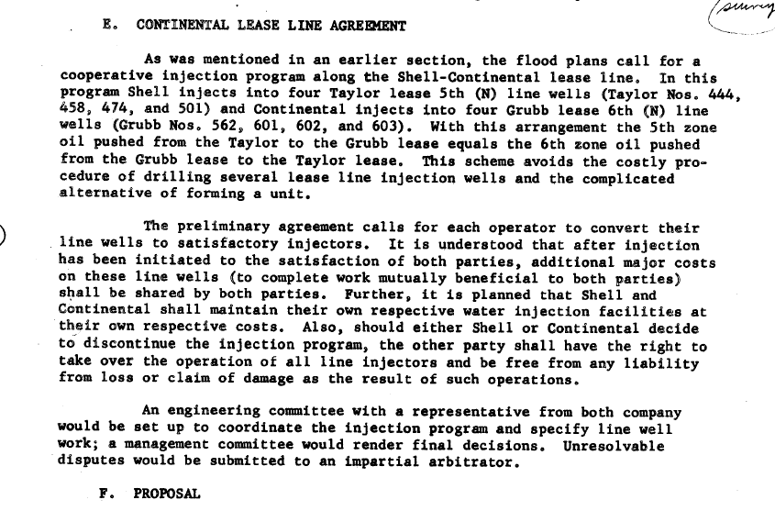

Appendices

Appendix A – Project Approval Letters

Appendix – Geologic Study (GS)

Appendix – GS(2) – Reservoir Properties and Geochemistry

Appendix – Engineering Study (ES) Figures

Appendix – Engineering Study (ES) Tables

Appendix – ES(1) - Core Analysis Study: TAY786 and TAY788

Appendix – ES(3) – Wellbore Diagrams

Appendix – Injection Plan (IP) Figures

Appendix – Injection Plan (IP) Tables

Appendix – IP(5) Continuous Casing Pressure Monitoring Approval

Appendix – W-IP(3) Geochemistry of Water Treatment Facility

Appendix – W-IP(4) Water Analysis Report and Non-USDW Demonstration

Appendix – SI(3) Ventura Water Treatment System and SDS

Appendix – OI(1) MASP and Field Rules

Appendix – OI(2) Letter to Offset Operator

